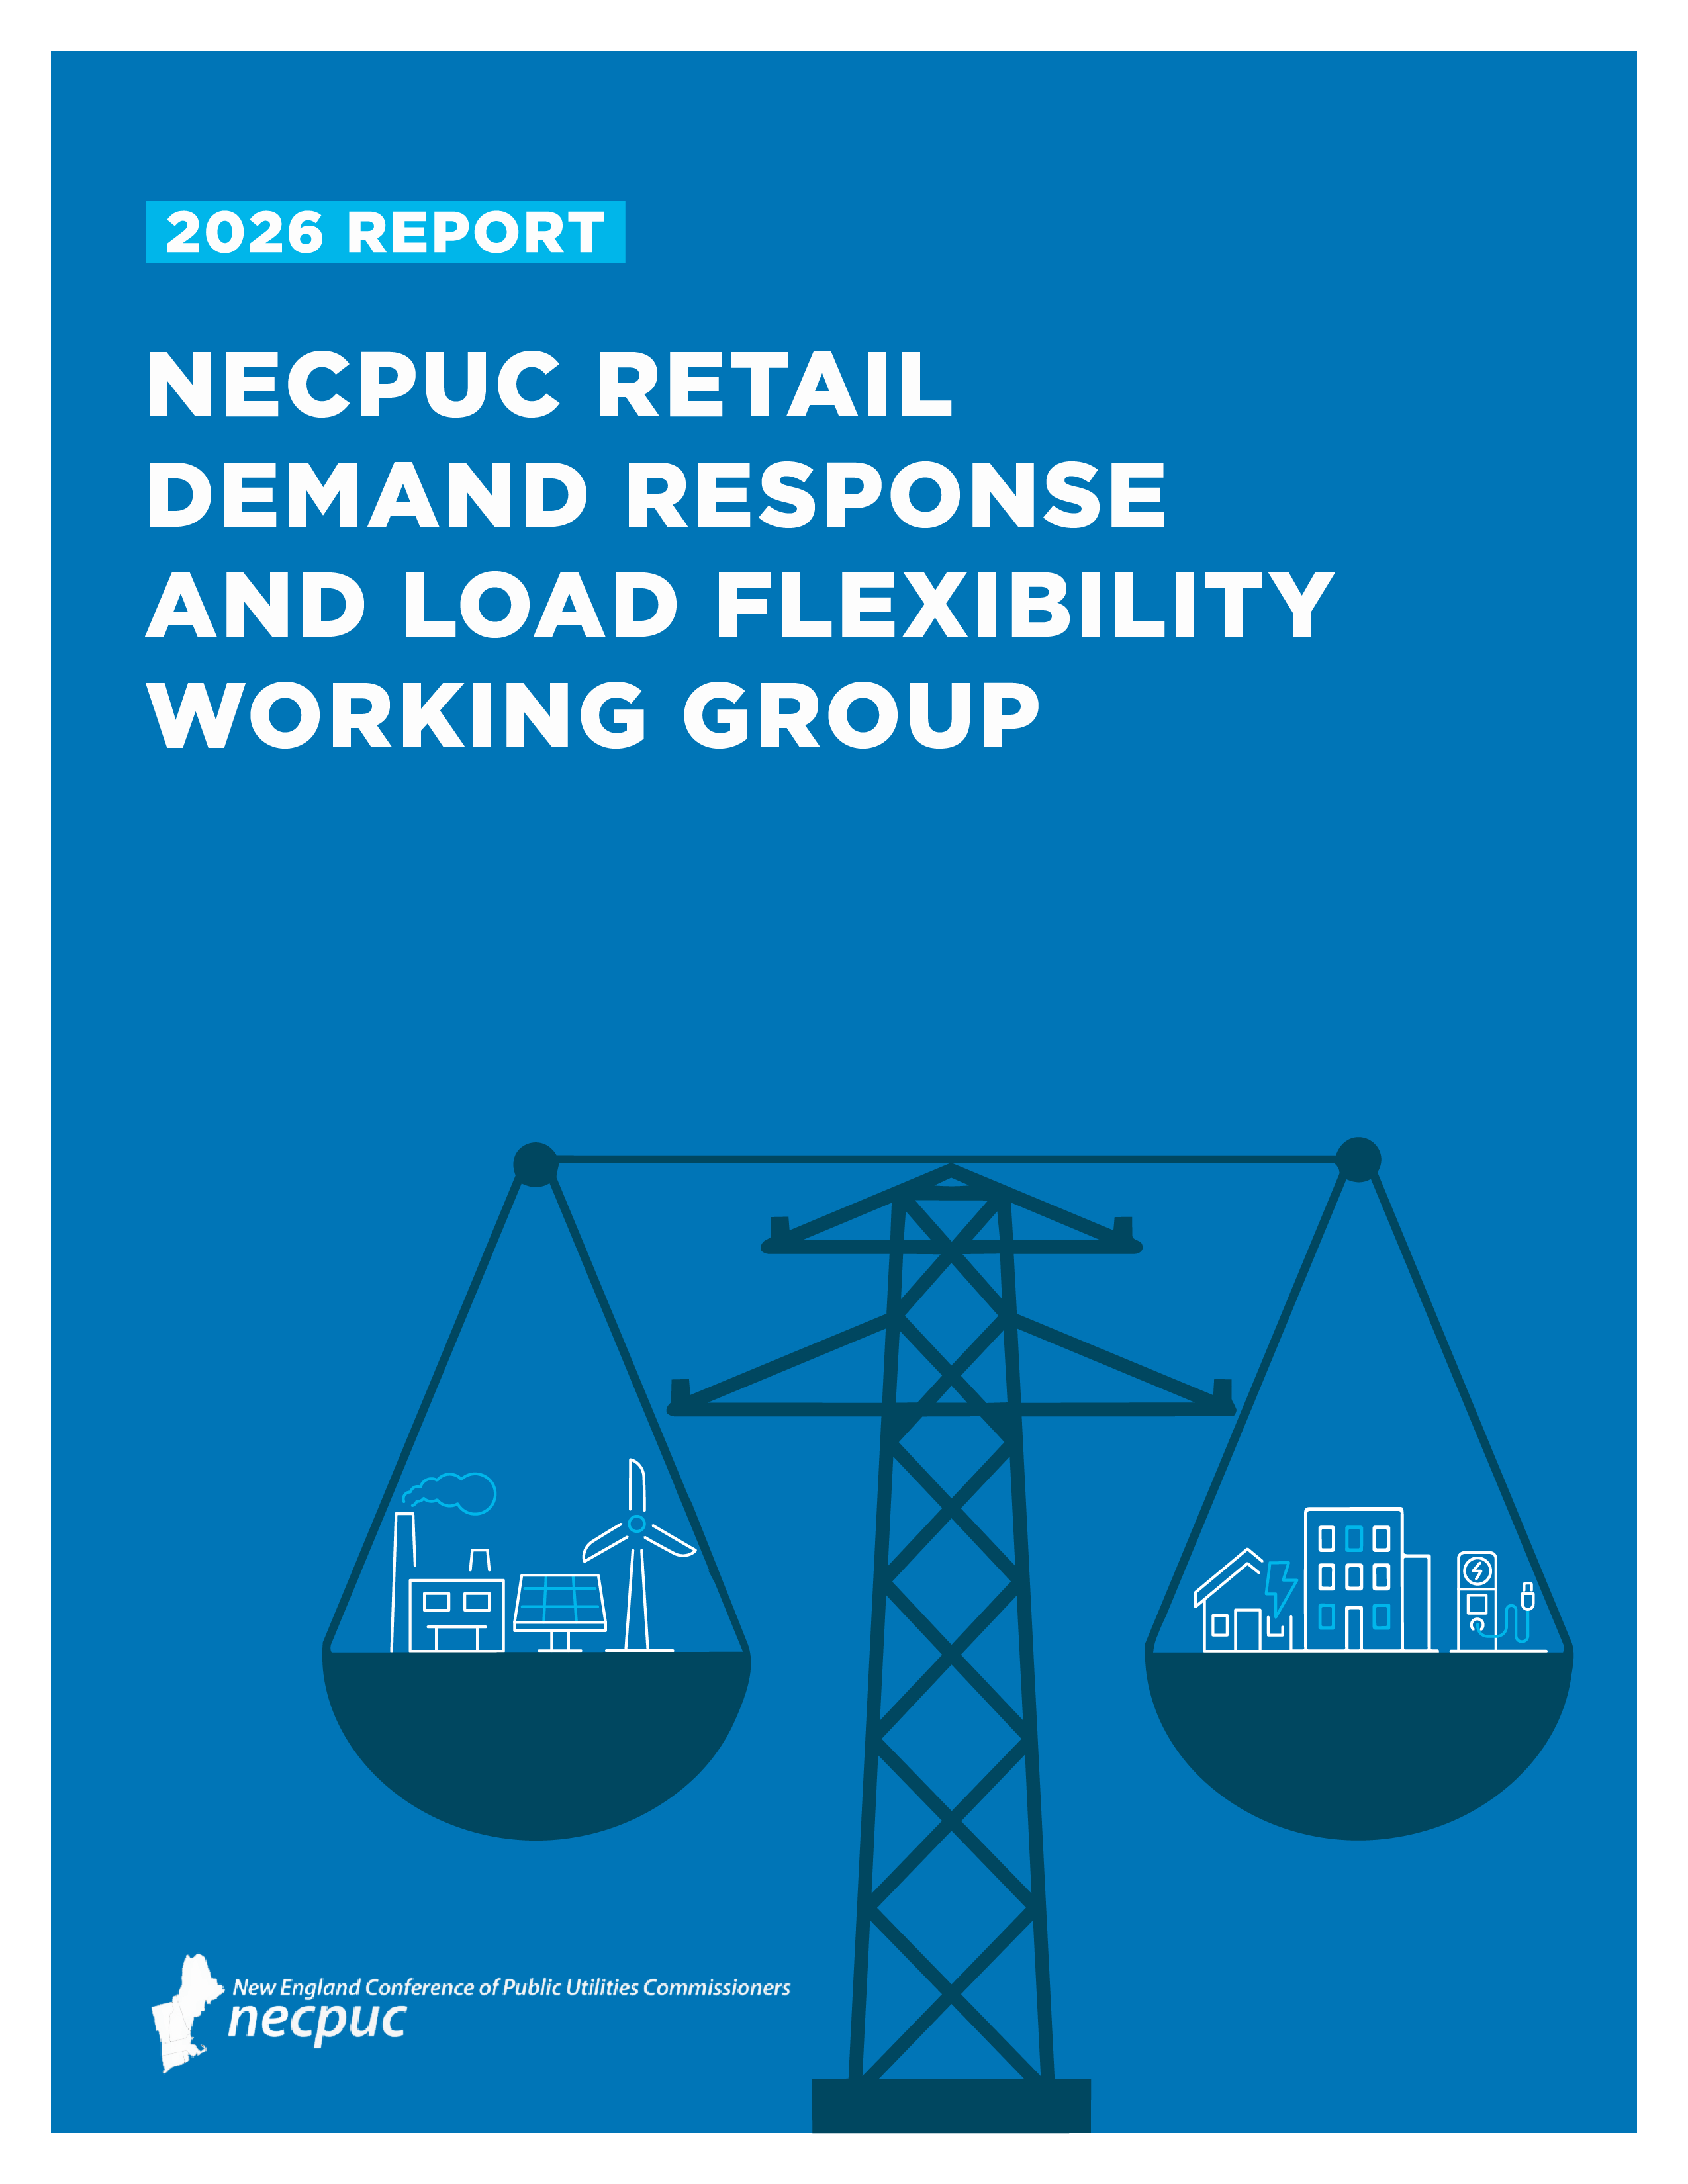
This report is a product of the NECPUC Retail Demand Response and Load Flexibility Working Group. While NECPUC is comprised of state regulators from the New England region, it has no independent regulatory authority. All recommendations and findings in this report are for advisory purposes only, and do not constitute official regulatory guidance from any NECPUC member regulatory body, or any other state government agency.
Report authors:
- George Twigg, NECPUC
- Mary Jo Krolewski, Vermont Public Utility Commission
- Michael Haskell, Maine Public Utility Commission
The authors wish to acknowledge the NECPUC Board of Directors for commissioning this work and supporting the Working Group process, in particular Maine PUC Chair Philip Bartlett who served as the Working Group’s chair.
We also wish to acknowledge significant ongoing support from several current and former Massachusetts regulatory staff: Ashley Gagnon, Josh Ryor, and Charles Dawson. Additionally, we would like to thank numerous staff at ISO-NE for their expertise, including Anne George, Kerry Schlicting, and Sarah Adams from External Affairs who helped facilitate our engagement with ISO-NE’s technical staff.
Lastly, we are grateful for the expertise and intelligence which our many presenters, commenters, and participants brought to the process.

Table of Contents
Section I: Executive Summary …………………………………………………………………………………….…………. 4
Section II: Working Group Charter, Goals, and Process ……………………………………….…….…………. 9
Section III: Participant Presentations and Comments ……………………………………….………..………. 17
Section IV: LBNL Technical Assistance Report ……………………………………….…………….…….…………. 30
Section V: Recommendations …………………………………………………………………………………….……….. 44
Section VI: Topics for Future Consideration ………………………………………………………….….…………. 57
Section VII: Appendix ………………………………………………………………………………………..………….……. 58

Section I: Executive Summary
The New England Conference of Public Utilities Commissioners (NECPUC) Retail Demand Response and Load Flexibility Working Group (the “Working Group”) was convened in early 2024 to explore how measures such as retail demand response, retail rates, and load flexibility can serve as resources to address current and future challenges in the ISO-New England region. The Working Group convened a series of workshops with interested parties, secured a technical assistance report from Lawrence Berkeley National Labs (LBNL, also known as Berkeley Labs), and held several follow-up discussions on specific topics.
The Working Group sought to identify pathways for retail demand side resources to help address the New England region’s dual challenges of peak demand growth and winter energy adequacy. According to ISO-New England (ISO-NE), regional peak demand is projected to as much as double, to between 51 and 57 GW, by the year 2050. At the same time, electrification-driven load growth and the region’s significant reliance on natural gas for both space heating and electric generation have raised concerns about future winter energy adequacy during extreme weather events.
At a time of significant regional uncertainty regarding future new generation resources and transmission investment, demand side options have the potential to deliver cost-effective resources in a timely fashion. The savings to ratepayers could be significant: ISO-NE estimates that if peak demand can be kept to the low of end the projected range (51 GW as opposed to 57 GW), that would reduce regional costs by $8 billion.
Source: 2025 Regional System Plan, ISO-NE
Through the course of a series of workshops and meetings held over an 18-month period, the Working Group found that there was significant regional interest in, and support for, developing additional demand side resources to help address these issues. The technical assistance report from Berkeley Labs added to this discussion, with a focus on (1) access of retail demand response resources to wholesale markets, and (2) an assessment of the applicability of retail demand response resources to the winter season.
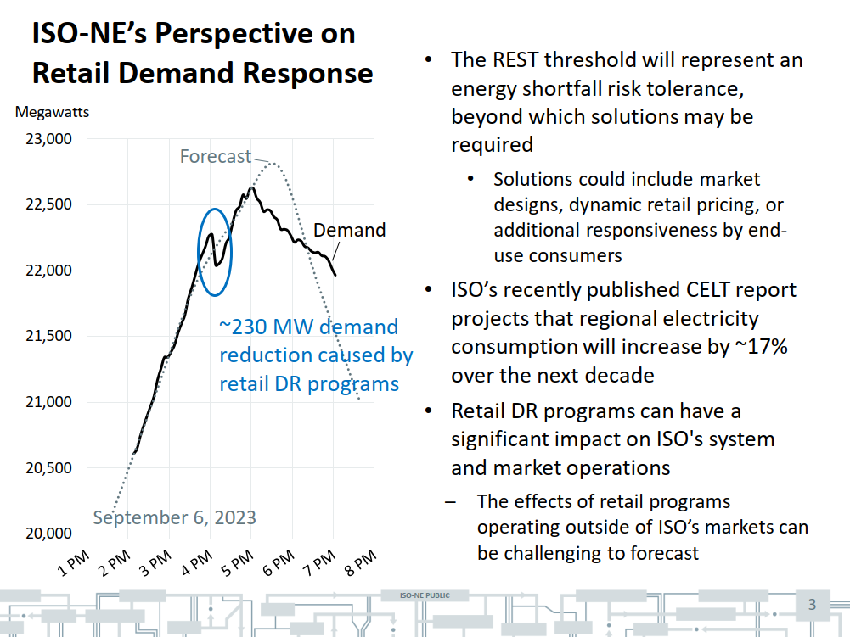
It bears noting that there are already significant retail demand response resources actively benefitting the New England region, even though they are not wholesale market participants. ISO-NE offered one example of this dynamic in its May 2024 briefing to the Working Group, when retail demand response programs delivered an observed 230 MW demand reduction in September 2023. This finding led to a productive series of discussions amongst the Working Group leadership, ISO-NE, and utility program administrators. The group identified opportunities for ISO-NE to gain greater visibility into retail demand response forecasted activities (i.e., event calls), and culminated in the development of a standardized template for utility program administrators to share critical information with ISO-NE. While the ultimate goal is for retail programs that are providing wholesale system benefits to be compensated in wholesale markets when appropriate, simply making these resources more visible to ISO-NE provides operational benefits, like how ISO-NE currently accounts for behind-the-meter solar resources in its forecast.
Source: ISO-NE 5/21/24 presentation
The Working Group process generated significant participant discussion and feedback on actions that could be taken to increase the use of retail demand response and load flexibility resources to address both peak demand growth and winter energy scarcity events. The LBNL study provided a lengthy set of additional recommendations that could be acted upon. In both cases, most of these fall within the purview of state regulators, acting either individually or as a region.
All of the Working Group’s meetings, participant presentations, and other materials are available online at https://www.necpuc.org/necpuc-retail-demand-response-and-load-flexibility-working-group/.
Some of the Working Group recommendations fell into the category of cross-cutting principles that state regulators may generally wish to consider for guiding their work in this area. Others are specific policy and regulatory recommendations. Both are summarized here and discussed more fully in the Recommendations section of this report.
Cross-Cutting Principles
Prioritizing affordability and cost-effectiveness | Retail demand programs should place a priority on affordability and cost-effectiveness. Advancing electrification rapidly may backfire if the region does not have reliable and affordable electricity to power heating and transportation systems.
Embrace energy equity and inclusive programs | Program design should include requirements to ensure that burdens and benefits of energy policy are equitably distributed across the states and residents of New England.
Prioritize reducing energy consumption with peak load reductions | As load grows through electrification, the clean energy transformation is projected to require increasing amounts of wind, solar, and battery storage. Shifting load by a few hours may address transmission needs, but not energy sufficiency needs during winter events. Addressing this challenge requires reducing energy consumption for many hours or even days.
Consider temporal and location-based values | Demand response program design should consider temporal and location-based values of efficiency. The optimal load shape paired with usage will look different at different times of the day or year. For example, optimized load shape for a cold February day with solar covered in snow is different than a sunny spring day with strong wind and hydro production.
Flexible load management is an equivalent solution | Seasonal peaks and winter energy adequacy concerns will drive the need for demand flexibility. Flexible load management can be viewed as an equivalent solution in transmission and distribution (T&D) planning, especially when considering non-transmission alternative (NTA) solutions. Demand shifting by rescheduling load to off-peak hours can avoid costly transmission upgrades. Operationally, demand-side flexibility improves the alignment of real-time generation with hourly demand, reducing reliance on stored fuels and batteries and lowering the risk of winter energy shortfalls.
Demand flexibility can be a winter peak solution | Though programs have historically targeted summer, demand flexibility can be a winter peak solution and should include increasingly important heating load. Winter demand flexibility can be created through measures such as time-varying rates, water heating control, automated demand response, interruptible tariffs, batteries, electric vehicle (EV) managed charging, industrial thermal storage, behavioral demand response, space heating control, and natural gas demand response.
Full range of ratepayer benefits should be considered | Flexible load management, when cost-effective, has many ratepayer benefits that should be considered, including:  (1) Reducing a load serving entity’s share of the costs of the bulk transmission system – also referred to as Regional Network Service reduction (RNS);  (2) Reducing a load servicing entity’s share of capacity costs;  (3) providing frequency regulation/spinning reserve revenues;  (4) generation constraint management on transmission and distribution systems;  (5) T&D investment deferral/T&D support; and  (6) improved resiliency and reliability of the power system.
Retail electricity rates and time-varying rates are enabled by AMI | The function of retail electricity rates is to recover utility’s revenue requirement in the most economically efficient and equitable fashion. There are various alternatives to standard volumetric rates, many of which are time-varying rates and are enabled by advanced metering infrastructure (AMI), which can encourage consumers to take part in demand response programs such as load-shifting.

Policy and Regulatory Recommendations
Consider traditional energy efficiency programs as a winter resource | As buildings continue to convert to electric heating systems, measures such as insulation and air sealing can be promoted to increase the efficiency of heat pumps, reducing baseload energy use around the clock. These measures also have potential as cost-effective measures for reducing peak demand as the region shifts back to winter-peaking status.
Explore the creation of new winter programs | The LBNL report found that there are relatively few retail demand response programs in New England operating during the winter season. State commissions may wish to consider initiating a proceeding or investigation to explore programs and technologies that have the potential to deliver cost-effective benefits.
Consider rate design options to support programs and technologies | Time-varying rates can be designed to incentivize flexible load management in ways not possible with standard volumetric rates. Truly enabling retail demand response and load flexibility measures will require supportive rates to maximize benefits, particularly those related to peak demand reduction.
Incorporate non-transmission alternatives into transmission planning | Retail demand response and storage resources could serve as cost-effective alternatives to building transmission. State NTA processes and ISO-NE transmission planning should be better coordinated to maximize transmission cost savings.
Scale winter-focused DR portfolios and managed EV charging | As the region shifts to winter-peaking, seasonal demand response portfolios should scale accordingly. For example, expanding winter demand response using smart thermostats, batteries, and managed EV charging, and launching local grid services/VPP offerings as loads shift to winter peaks, may all play a growing role in addressing both winter peak demand as well as winter energy adequacy needs.
Recognize and use existing tools in program design | Load shifting helps avoid or reduce the costs of T&D upgrades, but distinct measures may be needed for multi-day energy adequacy. ISO-NE, states, and utilities have existing tools that can aid the development of DR program design, including ISO-NE’s Probabilistic Energy Adequacy Tool (PEAT) and Regional Energy Shortfall Threshold (REST) tools.
Standardize and enable virtual power plants (VPPs) to participate in markets | State commissions should consider adoption of open communications standards that enable VPPs to provide both retail and ISO-NE services. Such standards could require utilities to provide interval usage, TOU and net-metering attributes, program and event flags, and basic billing interoperability so competitive suppliers and aggregators can offer retail demand response.
Conduct robust regional retail demand response potential studies, particularly focused on the winter context | Long-term regional planning could benefit from the development of robust demand response potential studies. The LBNL report noted that to date, potential studies such as this – particularly for the winter season – are very limited. If the region wishes to determine the degree to which retail demand response and load flexibility resources may help to mitigate regional peak demand growth and winter energy scarcity events, potential studies are an important foundational step in determining the possible scale of those resources.
Address conflicts between retail and wholesale dispatch of demand response resources | Dispatch orders from ISO-NE may conflict with those from retail program administrators, potentially resulting in significant financial penalties and operational difficulties for DER providers. This risk, in turn, may suppress the full development of retail demand response resources.  State regulators and ISO-NE should investigate and seek to resolve conflicts between retail and wholesale dispatch of demand response resources.
Monitor impacts of Order 2222 compliance | ISO-NE anticipates implementing Order 2222 by the fall of 2026. Participants held differing views on whether the Order 2222 tariff design in New England will effectively stimulate the development of additional demand response and load flexibility resources. State commissions can engage with relevant parties to monitor the impacts of Order 2222 as it takes effect, and assess the degree to which it is or is not supporting the deployment of new resources.

The Working Group did not exhaust all aspects of the topic of retail demand response. The following topics may be of interest for future consideration in some form:
- Natural gas demand response programs: This working group did not take up the issue of natural gas demand response. There was broad agreement that improving understanding of the potential for these products would be important in assessing the overall potential for demand-side resources to address regional winter energy adequacy challenges.
- Topics from the Working Group charter that were not taken up:
  - Real-time operational reliability (e.g., ramping); and
  - Matching demand with renewable energy generation

Section II. Working Group Charter, Goals, and Process
The NECPUC Retail Demand and Load Flexibility Working Group was created to assess how measures such as retail demand response, retail rates, and load flexibility can serve as resources to address current and future challenges in the ISO-New England region. The Working Group’s charter identified winter energy adequacy, peak demand growth, real-time operational reliability (e.g., ramping), and matching demand with renewable energy generation as topics to explore. Ultimately, the Working Group focused on the first two of these topics.
The Working Group included state regulators, industry representatives, and other participants and was created at the direction of the NECPUC Board of Directors in December, 2023, with Maine PUC Chair Phil Bartlett chairing the effort.
Additional commissioners participating were (in alphabetical order): Commissioner Riley Allen (Vermont PUC), Commissioner Abigail Anthony (Rhode Island PUC), Commissioner Pradip Chattopadhyay (New Hampshire PUC), Chairman Ron Gerwatowski (Rhode Island PUC), Commissioner Carrie Gilbert (Maine PUC), former Chairman Marissa Paslick Gillett (Connecticut PURA), and former Chair Jamie Van Nostrand (Massachusetts DPU). Commission staff representing both NECPUC and NESCOE agencies also participated. The Working Group was staffed by NECPUC Executive Director George Twigg, with assistance from Mary Jo Krolewski (Vermont PUC) and Michael Haskell (Maine PUC).
Purpose and Scope
Most regional discussions of possible solutions to the challenges outlined above have focused on the supply side, including the development of new generation resources and construction of new transmission. While supply side measures are critical to the solution set, there are significant opportunities presented by demand-side solutions. The Working Group examined retail demand response and load management programs overseen by state regulators that could serve as solutions to these regional challenges. The Working Group’s efforts included both retail program design and how individual retail programs may interact with wholesale electricity markets.
The Working Group’s goal was to develop a roadmap that the region can use to design and implement programs addressing the topics identified in the charter, at both the state and regional levels. Solutions for some elements overlapped, while others were separate and distinct (e.g., designing for peak demand reduction vs. designing for energy adequacy).
Considerations included:
- Best practices for retail and wholesale program design.
- What is working or not working in other jurisdictions.
- Retail/wholesale market interactions and requirements (financial and otherwise).
- Potential misalignment of incentives and needs between states and the region as a whole (i.e., benefits from a state-level retail program might primarily accrue to the regional/wholesale market).
- How to measure impact.
- Can ISO-NE define what a demand response product would need to look like to address the specific winter reliability challenge, using real or modeled data? How many hours of demand response would be needed to displace oil?
- What standards would ISO-NE require with respect to distribution company metering data?
- Are existing governance structures sufficient, or is something additional needed at the regional level?
Working Group activities included:
- A discussion with utility program administrators to solidify understanding of current programs, and the potential for new or adapted programs that address element(s) of the problem statement.
- Deeper dive w/ ISO-NE re: interrelationships between retail programs and wholesale operations and needs.
- Research support from LBNL to help develop the policy and regulatory roadmap that could serve as the basis for regional action.
- Peer-to-peer discussions amongst the states to compare program approaches and applicability.
Current and Future Challenges Facing New England
Constrained natural gas supplies and the electrification of the building and transportation sectors contribute to winter energy adequacy challenges as peak loads are forecast to substantially increase. Addressing the winter energy adequacy challenge has been ongoing discussion in the region for over a decade, and while ISO-NE’s most recent long-term energy adequacy assessment is somewhat more optimistic than previous assessments, the issue is far from resolved. Meanwhile, ISO-NE forecasts that peak demand will roughly double by 2050, with particularly high incremental transmission costs at the higher ends of their forecast.

Winter Energy Adequacy
The limited availability of natural gas in the ISO-NE region is a key contributing source of winter energy adequacy risk. New England’s energy shortfall risk is dynamic and will evolve as the region continues its clean energy transition. These challenges were most recently characterized by ISO-NE in its Operational Impact of Extreme Weather Events report. While the level of concern has receded somewhat for the immediate future due to factors such as the growth in behind-the-meter solar generation and energy efficiency, there remains the potential for energy shortfalls during extended periods of extreme cold weather.
Evaluating the possibility of a regional energy shortfall during extreme weather is therefore crucial. ISO-NE developed a robust energy adequacy assessment framework called the Probabilistic Energy Adequacy Tool (PEAT). Initial PEAT-based energy adequacy studies of 2027 and 2032 found the energy shortfall risk is manageable in the near-term, with risk increasing over the long-term. However, this assessment assumes the market will respond with new resources to meet projected demand increases associated with electrification; that offshore wind resources and associated transmission will be built; and that the gas system will remain reliable under the modeled scenarios.
PEAT assessments aided the development of the Regional Energy Shortfall Threshold (REST). Using magnitude and duration thresholds, REST will allow the region to determine its tolerance for energy shortfalls during extreme events in a manner that, assuming a reliable gas system, considers both reliability and cost.
ISO-NE has completed a number of revisions to its operating procedures (specifically, OP-21) to incorporate REST:
- OP-21 will now require seasonal energy assessments (upcoming winter and spring) and future seasonal assessments (5 and 10 years ahead).
- The revisions also establish REST with specific values: 0.25% tail, 3% energy shortfall magnitude, and 18-hour shortfall duration during any modeled 72-hour period. The revisions do not require any specific action should the REST be violated.
- The energy assessments are meant to be informative and serve as an alert to the region of increased energy shortfall risk.
- The magnitude of energy shortfall risk that is expected to be manageable was a key consideration in the development of the REST.
The region’s ability to effectively manage energy shortfall risk in advance of low probability 21-day winter events requires situational awareness of the risks and actions by ISO-NE and regional participants. ISO-NE’s 21-Day Energy Assessment forecast provides situational awareness of regional energy supplies, quantifies potential energy shortfall, and communicates advance warning that action may be necessary. With advance warning that action may be necessary, ISO-NE anticipates that market participants will make reasonable efforts to replenish stored fuel supplies, as applicable. ISO-NE’s well-established emergency operating procedures, including public appeals for conservation, facilitate additional relief in advance of any forecasted energy shortfalls.
Peak Demand Growth
ISO-NE forecasts increases in net energy use and seasonal peak loads over the next 10 years, driven primarily by the electrification of transportation and heating. The 50/50 net summer peak forecast grows by 2,094 MW (approximately 8.4%) from 2025 to 2034, while the 50/50 net winter peak forecast grows by 5,964 MW (approximately 29.7%) over the same period, driven primarily by the expected increase in electrified heating.
Source: 2025 Regional System Plan, ISO-NE
The forecasted increases in electrification will drive a convergence in average summer and winter peak demand. Over the forecast horizon, the difference in these forecasts shrinks from 4,747 MW in 2025 to 877 MW in 2033.
Beyond 2034, the 2050 Transmission Study, which assumes states achieve their energy and emissions policy goals, projects winter peak demand could reach between 51 and 57 GW – more than double New England’s previous all-time peak. The study also highlights the potential for demand side options, estimating that if peak demand can be kept to the low of end the projected range (51 GW) it would reduce regional transmission costs by $8 billion.
Source: 2025 Regional System Plan, ISO-NE
The magnitude of the annual peak will vary dramatically from one year to the next, depending on how cold or how mild a winter the region sees. By 2050, peak demand could vary 50% between a mild and a severe winter, driven by expected increases in electrification. Resources highly dependent on weather, like wind and solar, will drive a similar increase in the year-to-year variability of electricity supply.
Source: 2025 Regional System Plan, ISO-NE
The figure above shows the Economic Planning for the Clean Energy Transition (EPCET) study’s projected variation in peak demand between 2023 and 2050.

Working Group Process
The Working Group was initially chartered for a 12-month period that was subsequently extended to allow for additional participant feedback and the development of a technical assistance report from LBNL. The charter called for the Working Group to work on a regional basis to “bring together state regulators, industry representatives, and other participants to assess how retail demand response, retail rates, and load flexibility programs within the ISO-NE region.
To facilitate participation, the Working Group created a listserv which ultimately grew to 150 subscribers and held a series of public participant meetings which are further described below. All of these meetings were recorded, with the recordings and other meeting materials such as slide decks and participant comments posted and publicly available on the Working Group’s website.
The Working Group commenced its public meetings in February, 2024. For its initial phase of information-gathering, the Working Group held a series of briefings with participants from various disciplines:
- February 2024: Wholesale markets context
  - Stephen George, Director, Operational Performance, Training & Integration, ISO-NE
  - Dan Schwarting, Manager, Transmission Planning, ISO-NE
- March 2024: Utility perspectives
  - Hantz Presume’, Director of Transmission Planning, Vermont Electric Power Company (VELCO)
  - Bob Manning and Rob Whelan, Avangrid Networks
  - Josh Tom, National Grid
- May 2024: VPP and DER issues
  - Avery McEvoy, Senior Associate, Rocky Mountain Institute
  - Mary Sprayregen, Global Head of Regulatory Affairs & Market Development, Oracle
  - John Greene, Policy and Regulatory Affairs Manager, Piclo
- June 2024: Rate design
  - Dr. Sanem Sergici, Principal, The Brattle Group
  - Sarah Cullinan, Senior Director, Net Zero Grid Program, Massachusetts Clean Energy Center
  - Brandon Crawford, Regulatory Advocate, Citizens Utility Board of Minnesota
The Working Group also met informally during this period at the May 2024 NECPUC Symposium, with a panel discussion moderated by Chair Bartlett:
- Elizabeth Anderson, Chief, Energy & Ratepayer Advocacy Division, Massachusetts Attorney General’s Office
- Jennifer Downing, Senior Advisor, U.S. Department of Energy Loan Programs Office
- Stephen George, Manager, Operational Performance, Training, and Integration, ISO-NE
- Chris McCusker, Vice President, Energy Efficiency and Clean Transportation Programs, National Grid
After the initial information-gathering period, the Working Group held a series of meetings in the fall of 2024 to gather participant input and response to the proceedings to date. Agendas, recordings, and materials for those meetings are all posted on the Working Group’s page.
In early 2025, Working Group leadership and staff held several informal side meetings with representatives from ISO-NE and utility program administrators to discuss issues related to coordination of demand side resources between the retail and wholesale markets.
LBNL Technical Assistance Project
Over the course of 2024 and 2025, Working Group leadership and staff also worked on the development and submission of a “deep dive” technical assistance request to the US Department of Energy. The proposal was developed in the summer of 2024 and approved in September, 2024, followed by the creation of a project scope that fall.
A participant briefing on the initial phase of the project was held at the May, 2025 NECPUC Symposium, with an additional participant briefing on the remainder of the project held online in August, 2025.

Section III. Participant Presentations and Comments
The Working Group held a series of participant meetings over the course of 2024 and 2025 to improve its understanding of the issues identified in its charter, and to identify potential regulatory and policy solutions. Except for the panel discussion at the 2024 NECPUC symposium, each of these meetings was held virtually. Recordings of the meetings and materials presented were all posted on the Working Group webpage. Meetings were open to the public and advertised via the Working Group web page and email distribution list.
Takeaways from participant conversations
As summarized in detail below, the participant conversations provided valuable input and perspective for the Working Group. A few consistent themes emerged from those conversations:
- Incorporate non-wires alternatives into transmission planning
VELCO described Vermont’s process that requires 10-year utility plans to identify reliability issues and evaluate DR/storage and other NTAs with participant transparency. Better alignment between state NTA processes and ISO-NE transmission planning would be beneficial.
- Scale winter-focused DR portfolios and managed EV charging
National Grid and Avangrid suggested expanding winter DR using thermostats, batteries and managed EV charging, and for launching local grid services/VPP offerings as loads shift to winter peaks.
- Adopt default time-varying rates (opt-out) with customer tools
Brattle Group recommended moving customers onto opt-out time-varying rates (which Brattle asserts results in far higher enrollment than opt-in) and pairing rates with AMI-enabled guidance and bill comparisons so consumers can effectively respond. The MA Interagency Rates Working Group likewise urged near-term rate reforms and time-varying rates as AMI rolls out.
- Standardize and enable virtual power plants to participate in markets and
Rocky Mountain Institute’s (RMI’s) policy principles urged states and utilities to adopt open communications standards and allow VPPs to provide both retail and ISO-NE services with fair compensation. RMI also suggests requirements that utilities provide interval usage, TOU/net-metering attributes, program/event flags, and basic billing interoperability so competitive suppliers and aggregators can offer retail DR. Enel and Cpower suggested standardizing dispatch windows, baselines, telemetry and performance measurement across states to enable aggregation and make any local programs coordinate data/dispatch to avoid double counting with ISO-NE.
- Reference ISO-NE’s REST in program design
ISO-NE’s February briefing emphasized using REST as a reference in DR program design. ISO-NE noted that load shifting helps avoid or reduce the need for new transmission or upgrades but distinct measures are needed for multi-day energy adequacy. Union of Concerned Scientists suggests that program design targets should be informed by REST.
Initial Participant Input and Briefings
An initial round of briefings took place in early 2024, summarized below.
Establishing the context (February, 2024)
- Stephen George, Director, Operational Performance, Training & Integration, ISO-NE
- Dan Schwarting, Manager, Transmission Planning, ISO-NE
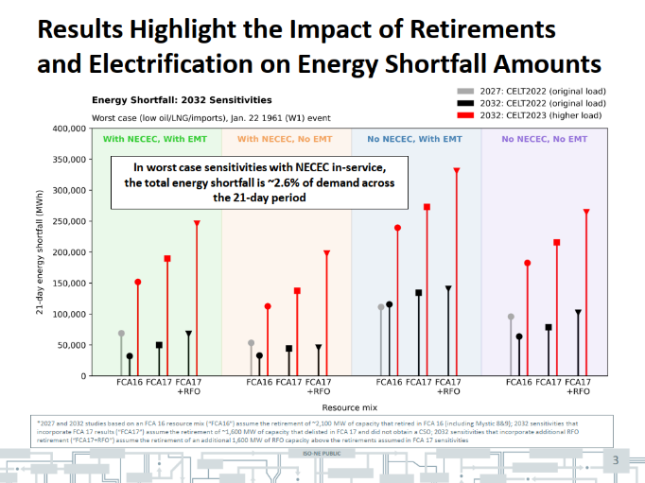
This meeting introduced the Working Group’s charge and provided a detailed look at ISO-NE’s PEAT and REST tools. The goal of the meeting was to get ISO-NE’s perspective on both winter energy shortfall risks, and overall expectations for peak demand growth – the dual areas of focus for the Working Group.
Stephen George from ISO-NE noted that winter energy shortfall risk is manageable through 2027, but begins to increase by 2032, as noted in the chart to the left. Timely additions of behind-the-meter and utility-scale solar, offshore wind and imports will be critical for mitigating those risks. One advance warning tool that could help guide the deployment of demand side mitigation resources is the ISO-NE’s 21-Day Energy Assessment forecast, which provides situational awareness of regional energy supplies and quantifies potential energy shortfalls. This forecast operationalizes the framework created by the PEAT analysis and will be informed by specific criteria specified through the REST analysis.
Source: ISO-NE 2/29/24 presentation
Source: ISO-NE 2/29/24 presentation
Dan Schwarting presented ISO-NE’s long-term load outlook, noting that electrification of transportation and heating will shift New England to a winter-peaking system in the mid-2030s, and that winter peak could double to 57 GW by 2050. He emphasized that load-flexibility measures —e.g., delaying EV charging and shifting space and water heating – can defer transmission expansion and that a 6 GW reduction in winter peak (from the high end forecast of 57 GW to the low end forecast of 51 GW) could save about $8 billion in transmission costs.
Both presenters stressed that shifting load addresses transmission constraints but does not solve multi-day energy resource adequacy challenges.

Regional planning and utility programs (March, 2024)
- Hantz Presume’, Director of Transmission Planning, VELCO
- Bob Manning and Rob Whelan, Avangrid Networks
- Josh Tom, National Grid
The second meeting shifted focus to state planning and utility programs, featuring presentations from VELCO, Avangrid, and National Grid.
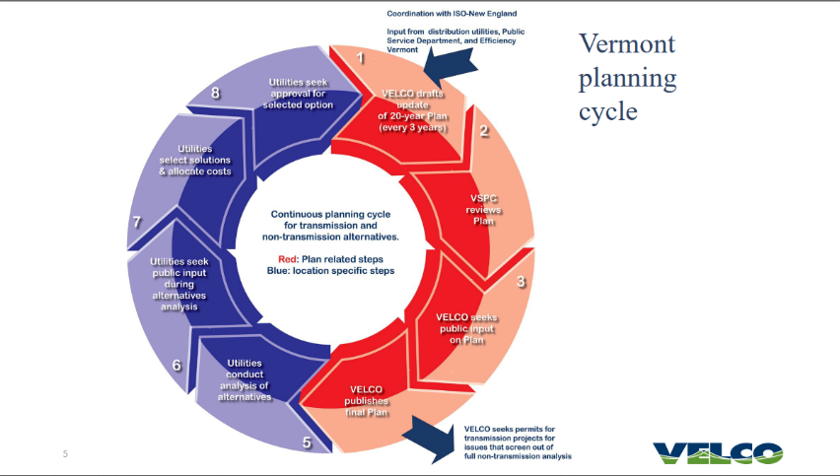
Hantz Presumé of VELCO described Vermont’s long-range transmission plan and the Vermont System Planning Committee, which requires utilities to prepare 20-year plans, identify potential reliability deficiencies and consider non-transmission alternatives like demand response and storage. He emphasized transparency and participant engagement in evaluating whether non-transmission alternatives can avoid or defer transmission upgrades.
Source: VELCO 3/29/24 presentation

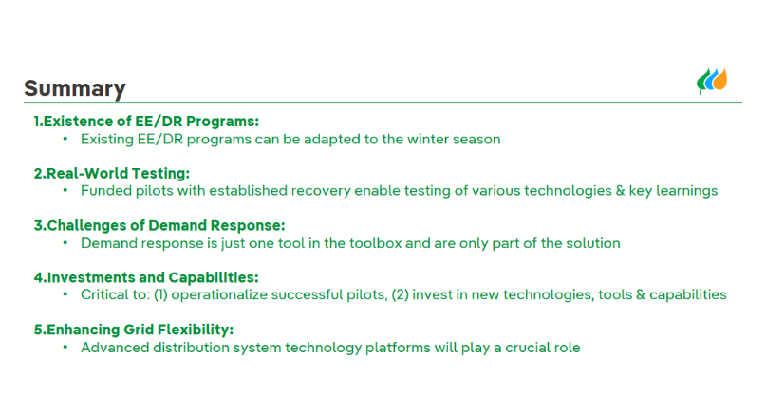
Avangrid’s presentation focused on United Illuminating’s winter demand response programs in Connecticut, highlighting the need to scale existing programs—energy efficiency, direct load control, battery storage, and managed EV charging—to meet growing winter peaks. Avangrid’s planning team described how demand forecasting, grid adequacy assessments, and evaluation of non-wires alternatives inform integrated planning. The presentation showcased demonstration projects on DER management and active network management in Connecticut and New York. Avangrid emphasized that demand response programs are just “one tool in the toolbox,” and that other strategies also play a role, e.g., adaptation of existing energy efficiency programs to the winter season and deployment of advanced distribution system technologies.
Source: Avangrid 3/29/24 presentation
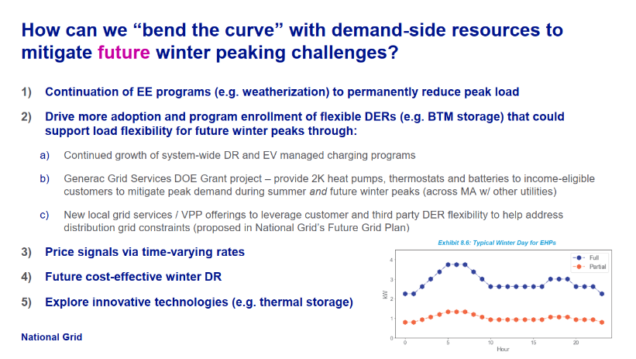
In its presentation, National Grid walked through its forecasting process, and the ways in which demand side resources are accounted for to adjust from a baseload forecast to an aggregate demand forecast. Using the year 2022 as an example, National Grid depicted how this resulted in a peak load reduction from 6,633 GW to 4,962 GW in its Massachusetts service territory, a reduction of about 25%. National Grid also provided a summary of their existing demand side programs: energy efficiency, demand response, and managed EV charging. Like the comments from Avangrid, National Grid noted states that “bending the curve” on future winter peaks will involve a range of measures, not just demand response, such as weatherization, time-varying rates, and “innovative technologies” such as thermal storage.
Source: National Grid 3/29/24 presentation
Demand-side innovation (May, 2024)
- Avery McEvoy, Senior Associate, RMI
- Mary Sprayregen, Global Head of Regulatory Affairs & Market Development, Oracle
- John Greene, Policy and Regulatory Affairs Manager, Piclo
This meeting highlighted innovative demand-side solutions, with presentations focused on policy and regulatory considerations (RMI), behavioral demand response (Oracle/Opower), and DER aggregation (Piclo).
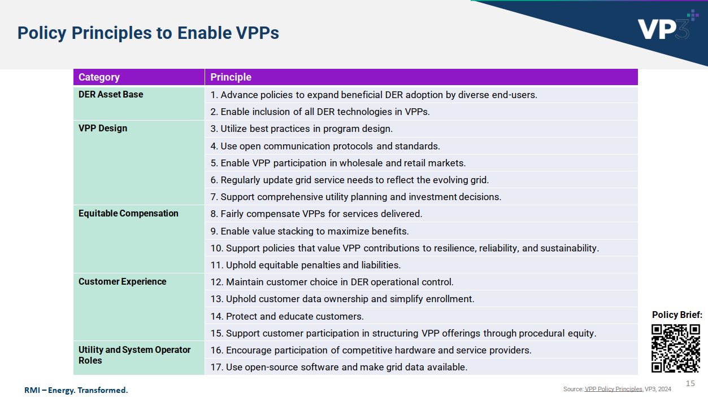
RMI presented its VPP principles framework. The broad objective of this framework is to enable regulatory conditions that support regulator and policymaker objectives, while also creating the conditions that will enable widespread adoption of VPPs. As a definitional matter, RMI defines a VPP as an aggregation of distributed energy resources (batteries, EV chargers, smart thermostats) that can balance loads and provide utility-grade services. RMI’s policy principles fall into five categories: DER asset base; VPP design; equitable compensation; customer experience; and utility and system operator roles. RMI provided several examples of how one or more of their VPP principles can be used to address specific circumstances faced by both regulators and VPP providers.
Source: RMI 5/3/24 presentation
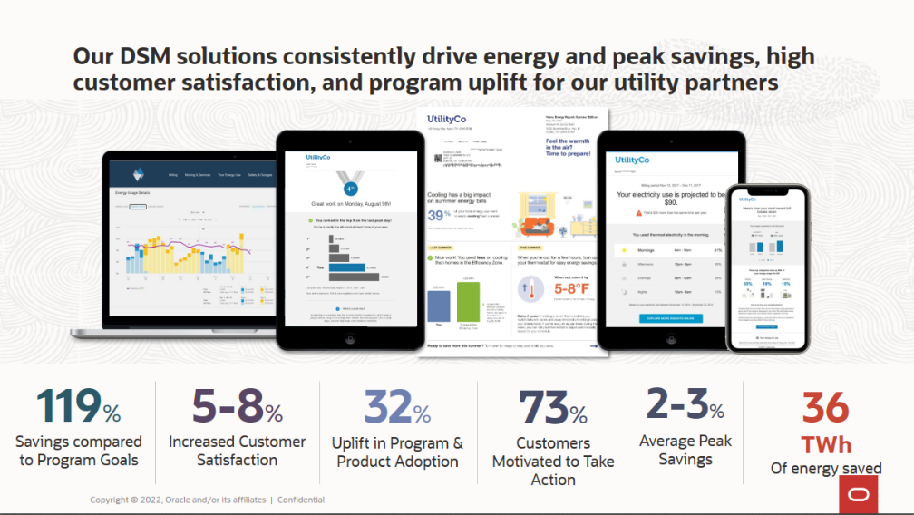
Oracle provided insights from its Opower peak management programs. According to Oracle, these behavioral demand response programs—digital messaging, gamification, and personalized coaching—deliver 2–3 % peak savings, increase customer satisfaction by 5–8%, and motivate most customers to act. Oracle emphasized the untapped potential of the demand response market: while 80% of future DER capacity will be behind the meter, fewer than 8% of U.S. households enroll in demand response programs. Like Avangrid and National Grid, Oracle emphasized the importance of a continued focus on passive demand side programs as part of an overall strategy for reducing peak demand and addressing winter resource adequacy.
Source: Oracle 5/3/24 presentation
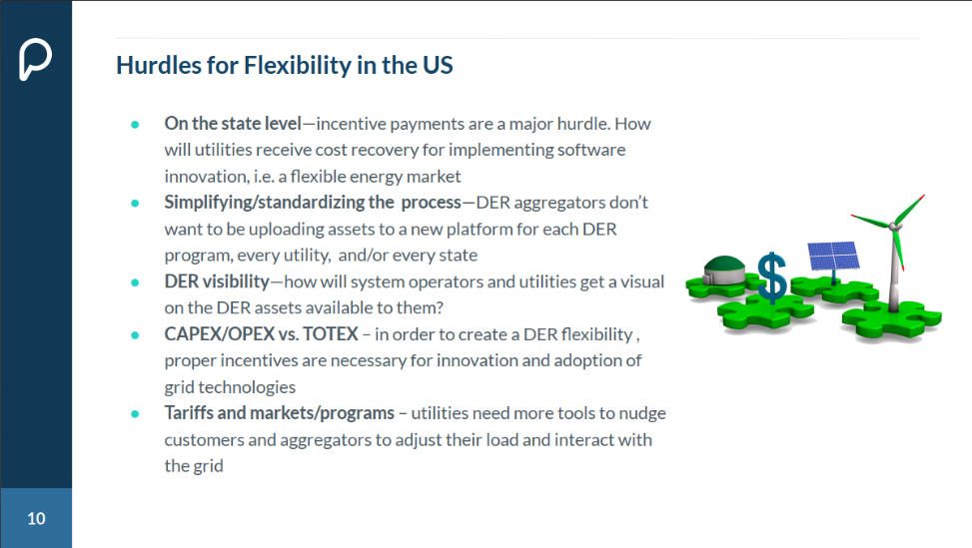
Finally, Piclo discussed its “independent DER-enabled flexibility marketplace.” This is a cloud-based marketplace placed between a utility and system operator on one side, and DER aggregators on the other. DER aggregators bid to win contracts from the utilities, and get paid for responding to operational signals. Piclo has registered 300,000 flexible assets and contracted over 2.6 GW of capacity using this platform. In the United States, Piclo is operating pilot programs in Connecticut (through a PURA innovative pilot program) and New York. Piclo has also worked extensively in the United Kingdom and offered several insights regarding how the United Kingdom has encouraged load flexibility in the marketplace.
Source: Piclo 5/3/24 presentation
NECPUC symposium panel on load flexibility (May, 2024)
- Elizabeth Anderson, Chief, Energy & Ratepayer Advocacy Division, Massachusetts Attorney General’s Office
- Jennifer Downing, Senior Advisor, U.S. Department of Energy Loan Programs Office
- Stephen George, Manager, Operational Performance, Training, and Integration, ISO-NE
- Chris McCusker, Vice President, Energy Efficiency and Clean Transportation Programs, National Grid
Held as part of the 2024 NECPUC symposium, this panel was moderated by Working Group Chair Bartlett and included panelists from the U.S. Department of Energy, ISO-NE, National Grid, and the Massachusetts Attorney General’s office (unlike the other Working Group meetings, this one was in person and was not recorded).
ISO-NE provided an update their energy adequacy work, reiterating the roles of their PEAT and REST tools. PEAT provides the framework for risk analysis of extreme weather events, while REST will provide a “reliability-based threshold that reflects the region’s level of risk tolerance” for energy shortfalls. As an example of the potential value retail DR could deliver for the region, ISO-NE noted that during a scarcity event on September 6, 2023, retail DR programs delivered approximately 230 MW in demand reduction. While these programs can have a significant impact on system operations, their effects can be difficult to predict because they are not operating within the wholesale market.
Source: ISO-NE 5/21/24 presentation
National Grid provided an in-depth look at its Connected Solutions program, detailing payments for thermostats and batteries (e.g., $50 sign-up plus $20/year for thermostats; $35/kW for summer dispatch and $200/kW for winter dispatch for batteries) and explaining the distinction between targeted dispatch (four to five events per summer for large customers) and daily dispatch (30–60 per year events using thermostats and batteries). The utility outlined strategies to bend the peak curve: continuing energy efficiency, growing flexible DER adoption, launching local grid-services/VPP offerings, implementing time-varying rates and exploring innovative technologies like thermal storage.
Rate design and affordability (June, 2024)
- Dr. Sanem Sergici, Principal, The Brattle Group
- Sarah Cullinan, Senior Director, Net Zero Grid Program, Massachusetts Clean Energy Center
- Brandon Crawford, Regulatory Advocate, Citizens Utility Board of Minnesota
The June meeting focused on retail rate design, with presentations from the Brattle Group, the Massachusetts Clean Energy Center, and the Citizens Utility Board of Minnesota.
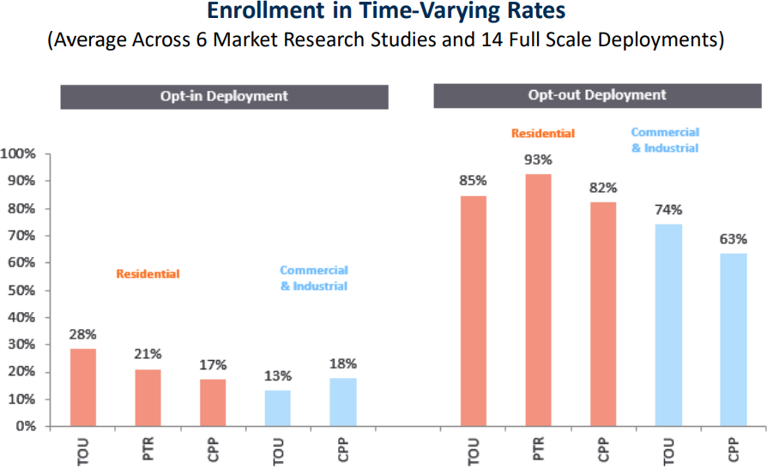
Brattle Group summarized evidence showing that time-varying rates prompt significant load shifts, and that opt-out designs achieve participation rates of around 85%, compared to opt-in designs seeing 20% enrollment. With respect to customers with low incomes, Brattle Group cited evidence that these customers do respond to time-varying rates, in some cases as much as other customers. Brattle Group noted that while winter season-specific time-varying rates are currently deployed to a very limited degree, that situation is evolving rapidly due to building electrification, the need for more load flexibility, and natural gas constraints. In terms of specific rate design recommendations, while there are many options and permutations to choose from, Brattle Group offered that a rate combining both time of use and critical peak pricing components is worth particular consideration, because that approach could address both daily load shifting (TOU) and managing system peaks (CPP). Brattle Group also noted that the advent of “prices to devices” technologies could help provide a level of automation that would increase the effectiveness of retail DR measures.
Source: Brattle Group 6/21/24 presentation
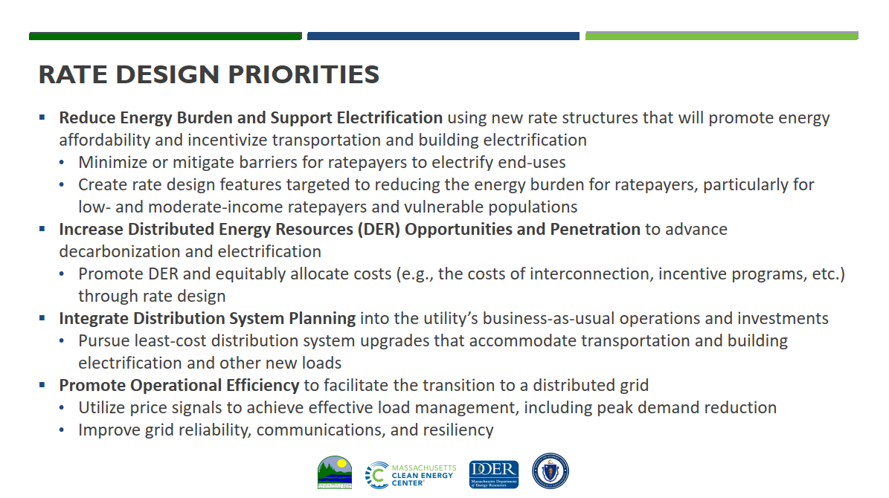
The Massachusetts Clean Energy Center provided an update on the Massachusetts Interagency Rates Working Group (IRWG), which is made up of four agencies from that state. The IRWG has several rate-design priorities: reduce energy burden while supporting electrification; increase opportunities for DER participation; integrate distribution planning; and encourage operational efficiency through price signals. The IRWG is planning three scopes of work: an assessment of current electric rates; a near-term rates strategy for the next five years; and a long-term rates strategy for 5-10 years into the future. The Massachusetts Clean Energy Center highlighted two examples of innovative rates: Central Maine Power’s heat-pump rate with lower winter volumetric charges and higher fixed charges, and a time-varying rate design from Hawaii which uses a 1:2:3 price ratio across day, evening and overnight periods to match prices with generation costs and emissions.
Source: Mass. CEC 6/21/24 presentation
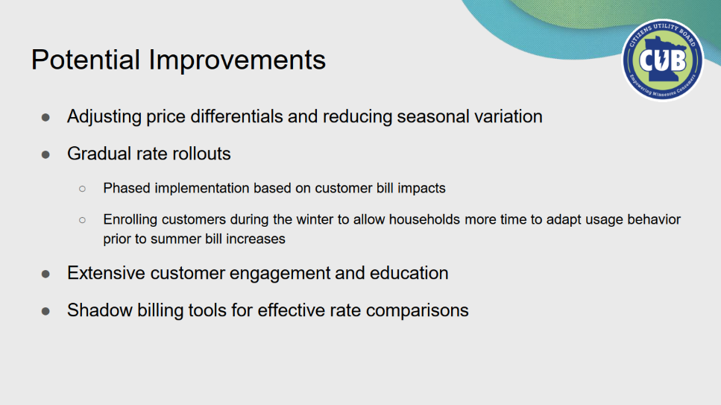
Offering a perspective from outside the New England region, Citizens Utility Board of Minnesota shared results from that state’s default time-of-use rate pilots. It found 1–1.6% peak-demand savings and up to 2% coincident peak savings, but minimal winter impacts. Citizens Utility Board of Minnesota noted challenges in customer engagement and savings such as season variation; customer education (particularly customer understanding of rate structures); limited residential load flexibility; and uneven impacts among customer subgroups (e.g., renters, seniors, etc.).
Source: CUB of Minnesota 6/21/24 presentation
Follow-Up Discussions
Following the initial series of briefings, the Working Group convened a series of follow-up discussions to explore specific issues raised by the discussions to date.
Retail regulation issues discussion (September, 2024)
This meeting was convened with participants to identify priority topics specific to retail regulation, including barriers to integrating retail demand response with wholesale markets. Written comments were solicited in advance, to facilitate the discussion.
CPower’s recommendations focused on four areas: (1) designing programs that are flexible with incentives that will attract a broad range of customers; (2) minimizing program complexity so that costs and benefits are easily understood by participants; (3) providing pathways to enable a wide range of eligible technologies; and (4) balancing program goals with state environmental policies, e.g., the regulation of emission control standards for participating generators.
Similarly, Icetec in its comments urged program designers to design with a goal of simplicity in areas such as enrollment and event notification. Icetec focused in detail on the topic of alignment between retail and wholesale market signals, noting that, for instance, “If the regional grid runs short of reserves but a retail program window looms just ahead, customers are forced to choose between wholesale market signals showing dire reliability warnings and retail program windows just a few hours away” (Icetec comments, Aug. 30, 2024). Also like Cpower, Icetec encouraged program design considerations to include carbon reduction impacts, for customers who may value those additional benefits. Lastly, Icetec emphasized the need for program providers to be viewed as trusted partners, in areas such as stewardship of customer data.
For its part, GridX’s comments focused on two areas: design of time-varying rates, rate education, and customer empowerment. In the area of rate design, GridX described time-varying rates as an essential component of an overall load flexibility strategy, particularly with the increased regional deployment of AMI. In terms of specific rate designs, GridX noted that while over 60% of customers nationwide have access to time-varying rates, only 7% of them are enrolled in such plans, suggesting that structures such as opt-out TOU rates should be among the options explored. With respect to customer empowerment, GridX suggested “personalized rate education” to improve customer enrollment and retention rates. GridX noted that several jurisdictions are experimenting with this approach, such as a program proposed by Xcel in Minnesota to provide tools such as a bill simulator which would allow customers to explore different rates and the impact of those rates on their bills.
The Community Power Coalition of New Hampshire (CPCNH) argued that competitive suppliers cannot offer retail DR programs because they lack access to time-of-use and net-metering data, billing systems can only process flat charges, and wholesale settlements do not credit exports. CPCNH suggested a focus on improving data access and pricing so DERs are treated as “resources” rather than “load reducers.” CPCNH further suggested the creation of a “DER Retail Market Platform” organized by a third party to facilitate contracts between DER providers and utilities, noting for instance that Piclo manages 60,000 assets and 19 GW of demand flexibility in the European Union and is undertaking pilot programs in Connecticut and New York.
Lastly, ISO-NE submitted comments that provided a summary of retail demand response program characteristics useful for it in predicting load behavior:
- Are programs voluntary, or mandatory?
- Parameters for utility load control program or calls for conservation/customer reductions;
- Program magnitude (in MW);
- Event triggers (i.e., system conditions);
- Timing and duration of conservation events; and
- Methods for communicating plans to implement conservation measures, if any.
As noted elsewhere in the report, sharing this type of information between retail DR program administrators (e.g., Connected Solutions) and ISO-NE is already underway.
Wholesale market issues discussion (October, 2024)
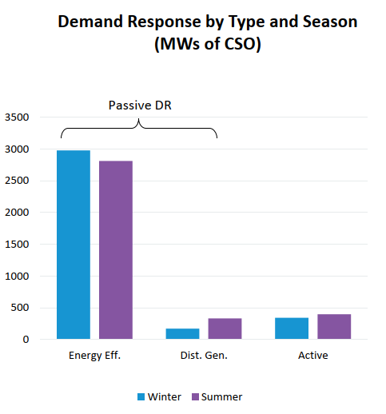
This meeting focused on issues specific to wholesale markets and began with a presentation from ISO-NE on the current market framework for passive and active demand response. ISO-NE explained that active demand-capacity resources must deliver at least 10 kW of curtailable load, report real-time telemetry and clear the energy and reserve markets. Aggregations must be located within the same zone and exceed 100 kW, and meters must record 5-minute intervals (1-minute for reserves).
During the discussion portion of the meeting, several participants questioned whether these size, locational, and telemetry requirements prevent retail programs from participating. Chair Bartlett asked how ISO-NE could gain visibility into the operation of state-run demand response programs that do not participate in wholesale markets. ISO-NE representatives replied that formal market registration is the most reliable way for ISO-NE to see and count on those resources; absent registration, only limited data-sharing discussions are under way. Commissioner Chattopadhyay questioned whether ISO-NE could forecast load more accurately by receiving advance notice of state program dispatches; ISO-NE staff said they could consider such notifications but stressed that participation in ISO-NE markets would still be necessary to meet metering and telemetry requirements. Chair Bartlett also asked Nancy Chafetz of CPower what level of incentive would be required for out-of-market resources to respond to winter reliability events; she promised to provide that information in a written follow-up.
Source: ISO-NE 10/4/24 presentation
Written comments on this session came from several participants and focused on Order 2222 implementation and resource adequacy. Advanced Energy United (AEU) urged NECPUC to push ISO-NE to fully implement FERC Order 2222 by allowing distributed-energy resource aggregations (DERAs) to participate in wholesale markets with less-strict submetering requirements. AEU noted that only about 500 MW of active demand response clears ISO-NE’s capacity market (roughly 2 % of peak load), and that other regions, such as PJM and NYISO, have much higher rates of demand response penetration.
CPower’s comments echoed AEU’s concerns, arguing that ISO-NE’s market design is too complex and risky for most customers. With only 2% of peak load participating, CPower advocated reallocating capacity costs and strengthening retail programs instead.
The Union of Concerned Scientists recommended that retail DR programs be designed to reflect ISO-NE’s probabilistic energy-adequacy modelling; highlighted that modelled load reductions of 10–20% significantly reduce energy-shortfall risk; and urged compatibility with the forthcoming REST metric.
Regional consistency (December, 2024)
This session focused on the topic of whether and how retail demand response programs should be harmonized across states, posing the following questions:
- What are the common elements that should be considered in program design and/or as operational requirements for new programs?
- Of these elements, which program design elements and/or operational requirements are the most important to prioritize?
- What are the barriers to operating programs in multiple jurisdictions, and what types of program design standards would be most helpful in overcoming them?
- Beyond addressing the barriers identified in response to the above question, what are the benefits of improved regional standardization of demand response/load management programs? Describe and define any benefits and provide examples to the extent possible.
Participants agreed that regional consistency (e.g., aligned dispatch windows, baselines, and incentives) could help aggregated DR operate at scale, but warned that chasing consistency should not come at the expense of good program design. Enel urged NECPUC to identify core elements that could be standardized while preserving flexibility. CPower argued for higher compensation for customers that can respond frequently and quickly. Participants also discussed aligning program windows with winter reliability needs and exploring a defined winter demand response product.
Written comments following this meeting were filed by CPower and Enel. CPower recommended standardizing core program elements such as dispatch hours, event triggers, baseline methodology, and performance measurement across states to facilitate regional aggregation. CPower added, however, that uniformity should not erode innovative program features and called for incentives that reward customers based on their responsiveness.
Enel similarly called for consistency but emphasized that payment rates should reflect customer capabilities (duration, frequency, and lead time) and that misaligned dispatch windows and baseline calculations across ISO-NE, Connected Solutions, and Massachusetts Clean Peak programs can diminish measured performance. Enel urged adoption of standard processes and transparent data-sharing protocols to reduce administrative burden.
Out of Market DR Coordination
One issue that arose over the course of the Working Group’s discussion was ISO-NE’s visibility, or lack thereof, into demand response products that were not participating in wholesale markets. Examples of these products would be the aggregated demand response programs managed by Connected Solutions. As an example, ISO-NE noted in a summary of an August, 2024 scarcity event that approximately 350 MW of “out of market” demand response showed up during the evening ramp, clearly in response to a retail-level event call. While the appearance of this resource was a welcome development during a scarcity event, its operational usefulness for ISO-NE operators was limited given that operators had no way to know when it would appear, in what size, and for what duration.
In response, the Working Group held several informal side meetings in the spring of 2025 with utility program administrators, state officials, and ISO-NE staff to discuss this issue. In the course of those discussions, it emerged that a subset of program administrators (utility participants in Connected Solutions) had started to informally communicate their plans with ISO-NE. Building on that initial work, the Working Group collaborated with program administrators and ISO-NE to develop a more formal template for sharing this information that began being used in the summer of 2025.
The objective of this information-sharing is that, if provided consistently over a period of time, the data provided could become reliable enough to be operationally useful for ISO-NE’s dispatch planning. In this fashion, it could become analogous to ISO-NE’s behind-the-meter solar day ahead forecast. This would potentially enable ISO-NE to dispatch a cleaner and less expensive combination of resources, e.g., retail demand response could displace a fossil fuel peaking generator.
ISO-NE has expressed a further desire that this information-sharing could be helpful in coordinating the timing of retail demand response dispatch. As these resources continue to increase in size, staggering the timing for when demand response dispatch begins and ends becomes increasingly important to ISO-NE in terms of balancing the regional transmission system (e.g., if every electric vehicle, heat pump, and residential battery storage system starts or ends its dispatch at precisely the same time, that could result in the very sudden appearance or disappearance of hundreds of megawatts).

Section IV. LBNL Technical Assistance Report
In June 2024, NECPUC submitted a proposal to the US Department of Energy for “deep dive” technical assistance. The proposal was approved in September 2024, and staff from Lawrence Berkeley National Labs (LBNL, also known as Berkeley Labs) ) were assigned to the project.
Over the course of the fall of 2024, Working Group commissioners and staff worked with LBNL staff to develop a statement of work for the project, which was finalized in November 2024. The statement of work included two tasks:
- Identifying pathways for retail demand response access to wholesale markets
- Retail winter demand response potential, program design considerations, and wholesale market value
Task One was completed in the spring of 2025 and presented to participants at the NECPUC Symposium in May 2025. Task Two was completed in the summer of 2025 and was presented to participants at a webinar in August 2025. The final report was also completed at that time. All of these materials were posted to the Working Group website. Publication of the report was followed by a comment period. Those comments were also posted.
Task One: Identifying pathways for retail demand response access to wholesale markets
LBNL broke this task into the following components:
- Background and context
- Demand response in existing ISO-NE markets
- Impact of FERC Order 2222 on demand response participation in ISO-NE markets
- Challenges to demand response participation in ISO-NE markets in the wake of Order 2222
- Opportunities for addressing those challenges
The context for this task was a desire by the Working Group to better understand the potential for retail demand response and load flexibility resources to mitigate demand growth, and the potential for these resources to help address winter resource adequacy needs, with a focus on the latter for the purposes of the Working Group objectives.
With respect to demand response activities in existing ISO-NE markets, the LBNL final report noted that retail program participants can participate in ISO-NE wholesale markets either directly or through an aggregator. The report found that doing so may be challenging for some participants for reasons such as:
- Size and location requirements
  - Demand Response Assets (DRAs) must in most cases be able to reduce demand by at least 10 kW
  - Aggregated Demand Response Resources (DRAs) must be able to reduce demand by at least 100 kW, with all resources being located in the same Aggregation Zone (a complication for, to take one example, utility programs which include multiple Aggregation Zones)
- Telemetry and metering requirements
  - Depending upon the market in question, ISO-NE requires either 1-minute or 5-minute telemetry
  - AMI may not have the ability or bandwidth to achieve this level of resolution, and even if it could, at this time it is not ubiquitous in most New England states
- Data sharing and participation models
  - There are no automated processes for retail programs and ISO-NE to share data and coordinate on demand response dispatch
  - As a result, ISO-NE does not have full visibility in the dispatch of retail demand response resources (timing, size, duration, type, etc.)
  - ISO-NE markets are not configured to take advantage of the full range of capabilities which DRRs can provide (e.g., they can both inject and withdraw energy)
- Baselines for calculating market performance
  - The ISO-NE wholesale market baseline is the “average of metered demand during the interval of dispatch … on preceding days”
  - If retail events happen during the days used to calculate the baseline, that can reduce the baseline and thus the calculated demand reduction, reducing compensation for those resources
Turning to FERC Order 2222, the LBNL report provided a brief overview of the compliance filing activities for that Order as it played out in the ISO-NE region, from the time of the Order’s issuance in September, 2020 to FERC’s acceptance in November, 2024 of ISO-NE’s final compliance filing. Order 2222 rules for the region will take full effect starting in November 2026, .

The LBNL report summarized the ISO-NE Order 2222 compliance filings as providing the following participation models and size requirements:
- Demand response can participate alongside distributed energy resources (DERs) that inject and/or withdraw energy (demand response distributed energy resource aggregations, or DRDERAs);
- Non-dispatchable resources can participate alongside flexible loads in the day-ahead energy market (settlement-only distributed energy resource aggregations, or SODERAs);
- Distributed energy resource aggregations (DERAs) can use existing participation models (binary storage facility, continuous storage facility, and alternative regulation resource);
- New participation models do not have minimum size requirements for the DERs that comprise DERAs;
- Both new and existing participation models have a minimum aggregation size of 100 kW; and
- Dual participation in retail and wholesale markets is allowed.
The ISO-NE compliance filings also specified roles for various entities under the Order 2222 construct. State regulators (Commissions) have authority over the resolution of aggregator-utility disputes; the roles assigned to distribution utilities by ISO-NE; and rules governing dual participation in retail and wholesale markets. Distribution utilities have authority to review DERA eligibility and impacts related to safety and reliability of the distribution system; and to override dispatch of DERAs to protect distribution system safety and reliability. Lastly, ISO-NE established rules for itself related to coordination, namely: requiring aggregators to follow utility rules and operate within the distribution system’s limits; requiring utilities to notify aggregators when distribution system constraints arise; and coordinating with distribution utilities to manage “conflicting operational directives” such as dispatch instructions.
As described in the LBNL report, the hoped-for impacts of the regime that will be created under their Order 2222 compliance filings are twofold. First, they will allow more customers to contribute DERs to DERAs by eliminating the 10 kW minimum demand reduction requirement. Second, they will diversify the types of aggregations that will be allowed by allowing for a greater variety of DER types to be aggregated; easing metering and telemetry requirements for certain aggregations; and reducing minimum size requirements for alternative regulation technology resources from 1 MW to 100 kW.
That said, the LBNL report notes that even with the changes provided for under the Order 2222 compliance filings, various challenges may yet remain for retail programs to participate in ISO-NE wholesale markets. Some of these challenges related to DERAs generally, while others are specific to the issue of dual participation in retail and wholesale markets.
For the former, some of the challenges noted are like those that exist under the pre-Order 2222 regime, such as metering, telemetry, and locational requirements for DERAs. Additional challenges relate to submetering, utility data systems, dispute resolution, and utilities lacking frameworks for overriding ISO-NE dispatch signals. Refer to the LBNL report for detailed discussion of each of these topics.
For the latter, two primary challenges specific to dual participation were noted in the LBNL report. First, complexities related to the baseline for market performance calculations. Second, the lack of a framework for avoid situations of double compensation (ISO-NE and a utility make overlapping requests) and operational risks (ISO-NE and a utility make conflicting requests). The scenario of conflicting requests could also lead to aggregators being exposed to significant non-performance penalties.
The final portion of Task One, opportunities for addressing these challenges, will be discussed in the Recommendations section which follows the discussion of Task Two below.
Task Two: Retail winter demand response potential, program design considerations, and wholesale market value
For Task Two, LBNL’s analysis included these components:
- Description of existing winter demand response programs and rates in the New England region;
- Assessment of how these programs and rates align with the timing of winter energy shortfalls;
- Overview of winter demand response value in the context of the 2024 Avoided Energy Supply Components (AESC) study;
- ISO-NE wholesale market revenues; and
- Review of existing research on winter demand response potential in the region.
Existing winter demand response programs
For the review of existing winter DR programs, the LBNL report includes a review of programs and rates from 21 New England utilities. The review screened for rates and programs with the following attributes:
- Incentives to flex load in the winter (this could mean either programs with year-round incentives, or winter-specific).
- Rates with either a technology component (e.g., a TOU rate for buildings with battery storage) or a dynamic pricing component based upon the price of electricity as driven by grid conditions in the winter.
That review yielded 14 programs and 35 rates which met the screening criteria:
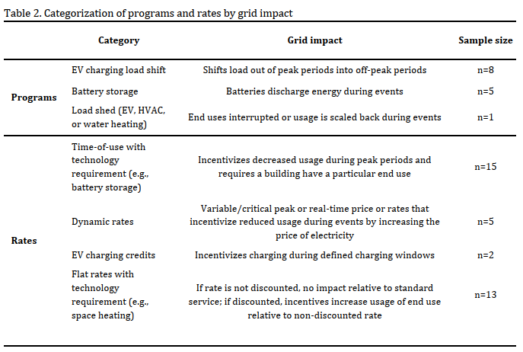
Source: LBNL Technical Assistance report, pg. 6
Program alignment
The LBNL report then provides a review of these rates and programs for alignment with winter energy shortfalls, as described in ISO-NE’s Operational Impacts of Extreme Weather Events report. The review examined the types of shortfalls (timing and duration) and the alignment of rates and programs with each type of shortfall.
For shortfall types, the following scenarios were identified:
- Evening/nighttime shortfall (approximately 6pm – 12am)
- Morning and evening/nighttime shortfall
  - Approximately 6am-12pm and 6pm-12am
  - Energy surplus midday or overnight
- Extended shortfall of at least 12 hours

The LBNL report contained the following observations based upon its review of program alignment:
- Battery, EV charging load shift, and load shed programs generally targeted evening peaks. That said, not all programs aligned perfectly with projected evening shortfalls, particularly shortfalls which extended later into the evening (e.g., a program or rate might end its event at 9pm even though the shortfall extends until 12am).
- No programs aligned with morning shortfalls. Indeed, some programs might exacerbate morning shortfall periods, based on their designed hours of operation.
- No programs aligned with extended shortfalls (12 hours-plus). For instance, load shifting and battery storage programs had a maximum length of 3-6 hours.
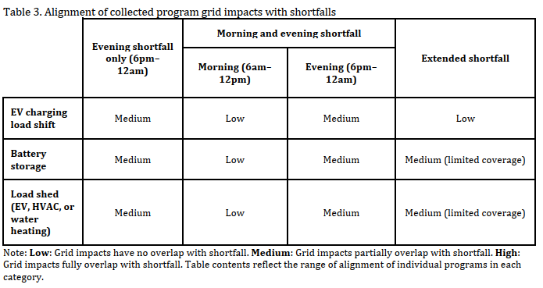
Source: LBNL Technical Assistance report, pg. 8
The LBNL report made several further observations related to winter programs. First, it noted that some programs have limits on the number of events which can be called during a specified period (month, year, etc.). In some scenarios, the number of allowable events could be quickly exhausted during an extended winter shortfall (setting aside the practical issue of customer tolerance for an extended number of events within a short time period).
Second, the LBNL report suggests that some consideration may be warranted for overriding default program parameters in the case of a grid emergency. Lastly, the report suggests that programs may need to examine the types of incentives being used to encourage participation, specifically whether event-based performance incentives might be more effective than one-time enrollment incentives.
With respect to rates, the LBNL report found greater alignment with winter shortfalls, in particular morning shortfalls. Many TOU rates had higher-priced hours in both the morning and the evening, and did not necessarily always align with the shortfall periods as defined by the ISO-NE study. The LBNL report further found that some rates are based on TOU while others are based on day-ahead pricing. To the extent day-ahead pricing sends a stronger pricing signal to customers in advance, that design might be more effective for mitigating winter shortfalls.
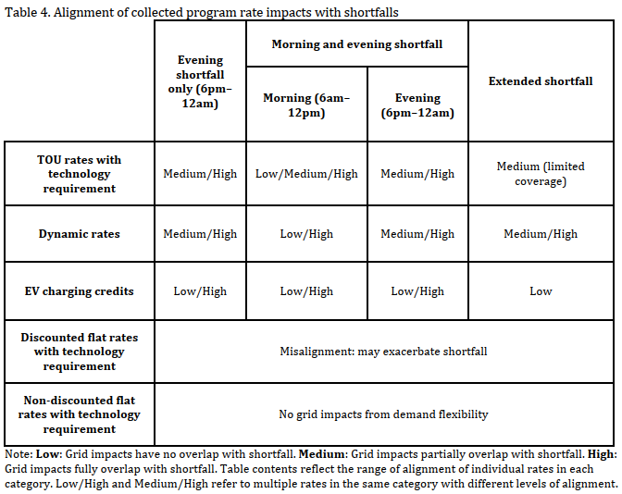
Source: LBNL Technical Assistance report, pg. 10
Lastly, the LBNL report noted that some rate designs could exacerbate winter shortfalls. It provides the example of one rate for residential electric resistance heating in which the rate falls after 600 kWh of monthly usage. While the intent of this rate design may be to address consumer affordability issues, it would have the potential to create a misalignment between consumer costs and market pricing. The LBNL report notes that in other parts of the country, a discounted rate can be paired with interruptible load programs to reduce potential grid impacts during shortfall periods.
Demand response value and cost-effectiveness
The LBNL report then examined the issue of winter demand response value, noting that if programs are not cost-effective, they will not be included in retail demand side program portfolios. The discussion in this area included an assessment of the avoided costs related to energy, capacity, demand reduction induced price effects (DRIPE), compliance and non-embedded environmental costs, transmission and distribution, and reliability.
For the energy avoided costs component, the LBNL report observed that the cost-effectiveness of winter programs could be negatively impacted by both the characteristics of these programs as well as how the AESC study makes its calculations. For the former, the report notes that “Energy avoided costs can contribute to winter demand response value, though the value stream may be small due to the limited number of hours that demand response reduces load and the avoided costs being in units of $/MWh.” For the latter, the report notes the potential misalignment between the AESC costing periods and the periods during which winter demand response events would be likely to be called.
In the area of capacity, the LBNL report notes that there is limited potential for value from this component until at least the year 2032, due to expectations that the region will continue to be summer-peaking until that time. As the region shifts to a dynamic in which the installed capacity requirement is being driven by winter-peaking loads, the value stream from capacity-related avoided costs will also shift.
With respect to DRIPE, the LBNL report finds that as with energy avoided costs, DRIPE avoided costs could contribute to winter demand response value, but that this value would be similarly limited due to the limited number of hours during which programs operated and the avoided costs in question being measured in $/MWh. The report makes a similar finding for the potential avoided cost value from compliance and non-embedded environmental costs (e.g., renewable portfolio standard policies).
The LBNL report finds that winter demand response programs can reduce, defer, or avoid the need for incremental investments in both transmission and distribution infrastructure, but only when (1) the system is winter-peaking, and (2) the demand reductions occur during the hours of that peak.
Finally, with respect to reliability-related avoided costs, the LBNL report found that winter demand response programs could reduce peak demand, which would in turn reduce the amount of unserved energy, but only for years in which there are non-zero winter capacity prices.

ISO-NE wholesale market revenues
The LBNL report notes that demand response measures can earn revenue from the ISO-NE energy, ancillary services, and capacity markets. A more complete discussion of issues related to wholesale markets is included in Task One.
Winter demand response potential
The LBNL report surveyed the region for existing studies characterizing winter demand response potential. Two such studies were identified, one from Unitil Massachusetts and a statewide study for New Hampshire.
Both studies had significant limitations in terms of their overlay with the ISO-NE winter shortfall analysis. Specifically, the time ranges covered by the studies were 2022-2024 for the Unitil Massachusetts study, and 2023 for the New Hampshire study, both falling well in advance of the ISO’s 2027 and 2032 periods of analysis. There are also differences in load growth forecast assumptions, a lack of analysis of demand response potential in the context of energy shortfall events, and a lack of granularity in terms of the hours of winter peaks (i.e., morning vs. evening).
In terms of results, the Massachusetts Unitil study found potential savings vs. baseline ranged in 2024 from 1.2% (achievable business as usual scenario) to 2.0% (achievable maximum potential), which translated to annual savings ranging from 0.97 to 1.61 MW vs. a baseline of 81.0 MW.
The New Hampshire study did not express its savings in % vs. baseline, only in MW, so it is difficult to compare the two results. Of note, the New Hampshire study found far more potential for winter savings in the commercial sector as opposed to the residential sector. For instance, for the month of January, 2023, the study found active demand response potential ranging from 1-3 MW for the residential sector versus 13-31 MW in the commercial sector.
The recommendations section below includes discussion of approaches taken by two winter-peaking utilities in the Pacific Northwest for conducting winter demand response potential studies, which New England participants could consider adopting.

Recommendations from LBNL
The report includes numerous recommendations for participants to consider. The recommendations are listed in summary form here. Refer to the LBNL report for a fuller discussion of each.
Task One: Identifying pathways for retail demand response access to wholesale markets
The LBNL report noted a range of actions which could be taken to address the challenges posed for retail demand response resources seeking to participate in ISO-NE wholesale markets:
- Metering and telemetry
  - State regulators can engage with their distribution utilities to determine whether existing and/or planned AMI can support the granularity of metering and telemetry required under ISO-NE’s Order 2222 compliance filing (i.e., 5-minute metering and 5- and 1-minute telemetry).
  - Conversely, as utilities are developing their proposals for new AMI infrastructure, they can propose systems that will support these metering and telemetry requirements.
  - State regulators and ISO-NE can explore alternative approaches to telemetry and metering requirements such as those in CAISO and NYISO.
- Size and locational requirements
  - State regulators can ask utilities to assess how size and locational requirements would impact their ability to act as aggregators (the report suggests, for example, asking Eversource if Connected Solutions can meet the 100 kW minimum in each Aggregation Zone)
  - State regulators and ISO-NE can explore alternative approaches to locational requirements.
- Double-counting DER load impacts related to submetering
  - State regulators can engage in discussions with ISO-NE, utilities, and DER providers on the potential for using submeters embedded in DERs, to avoid the additional costs associated with utility-installed submeters, if the embedded submeters can now – or in the future – meet ISO-NE accuracy requirements.
  - State regulators can ask utilities if their existing AMI and data systems can receive communications from behind the meter DERs and can separate the impact of those DERs from building load.
- DERA registration
  - State regulators can ask utilities to propose frameworks for assessing the safety and reliability of DERAs on the distribution system. Coordination of these frameworks across the region could support standardization of safety and reliability requirements. Regulators can also develop streamlined interconnection processes to enable customers to sign up more quickly for DERAs, and to require utilities adopt the IEEE-1547 standard for DER interconnection if they have not already done so.
  - Utilities can develop systems that automatically determine various aspects of DERs: whether a DER is part of an asset participating in ISO-NE wholesale markets, to avoid double compensation; whether DERs are located in aggregation zones and metering domains associated with DERAs; the incremental safety and reliability impacts of DERs. Such systems could also be designed to automatically share interconnection and other data with aggregators.
- Aggregator access to customer and grid data
  - State regulators can require utilities to develop systems that enable aggregator access to: DER location and interconnection information to support DERA registration; hosting capacity, load characteristics, and distribution system data to support DER operation; and customer metering and telemetry to support DER operations and settlement with ISO-NE.
- Dispute resolution and dispatch overrides
  - State regulators can establish transparent dispute resolution processes for issues that arise between utilities and aggregators related to safety, reliability, and eligibility.
  - State regulators can ask utilities to develop frameworks for how, why, and when ISO-NE dispatch signals to DERAs could be overridden.
- Baselines for market performance calculations
  - State regulators can discuss with ISO-NE the possibility of changing how baselines for DRDERAs are calculated, by excluding days when retail program events are called, which would increase calculated wholesale market performance.
  - Utilities can share retail program event participation data with ISO-NE, to facilitate a better understanding of which customers are participating, and how that impacts the baseline calculation.
- Double compensation and conflicting grid services
  - State regulators can establish policies for prohibiting double compensation, by addressing the scenarios of switching (allowing customers to participate in retail and wholesale programs at different times); parallel participation (only compensate a customer for either wholesale or retail dispatch responses); and non-identical participation (prohibit a retail program participant from participating in a wholesale market while providing the same service to a retail market).
  - State regulators, utilities, DER providers, and ISO-NE can develop frameworks for avoiding conflicting dispatches, including the creation of criteria for when each type of dispatch should take precedence.
Task Two: Retail winter demand response potential, program design considerations, and wholesale market value
The LBNL report included several recommendations related to the potential for winter demand response programs and rates to help address winter energy shortfalls in the region.
- Alignment of program and rate impacts with winter energy shortfalls
  - Programs
    - Program administrators can consider establishing morning event windows and extending evening event windows to increase the overlap of program grid impacts with energy shortfalls.
    - Program administrators can consider shifting EV charging load to the day preceding and or following to address long duration (12+ hours) energy shortfalls.
    - Emergency event rules allowing for standard program guidelines to be overridden in the event of a grid emergency could help programs address winter energy shortfalls and could offset constraints posed by a small maximum event count.
    - Performance incentives, which reward energy or demand reductions during events, may encourage participation in events that address shortfalls more effectively than enrollment incentives.
  - Rates
    - Utilities can consider creating a morning on-peak period and expanding the length of on-peak periods to better align TOU grid impacts with energy shortfalls.
    - State regulators can consider requiring utilities to incorporate dynamic components such as day-ahead pricing into TOU rates to incentivize greater demand reductions during energy shortfalls.
    - State regulators can consider requiring interruptible components for discounted flat charges to encourage demand flexibility.

- Winter demand response value
  - State regulators can consider requesting that utilities use a subset of the hourly avoided costs in place of the seasonal on-/off-peak weighted average avoided costs to value winter demand response programs.
- Winter demand response potential
  - Program administrators can report technical, achievable, and economic winter demand response potential.
  - Future studies can estimate demand response potential over long time horizons to account for the adoption of new technologies and support planning for energy shortfalls.
  - Program administrators can estimate winter demand response potential under a range of scenarios.
  - Program administrators can base potential estimates on peak demand forecasts that account for expected technology adoption from programmatic and market-based adoption.
  - Program administrators can consider a broad set of demand response technologies and time-varying electricity rates in future potential studies.
Participant Comments and Recommendations
The LBNL report was posted for public review and comment on the NECPUC Working Group website. The comments are each summarized below.
Maine Office of the Public Advocate (OPA)
- Winter demand response based on dynamic rates will be limited because heat pumps are not designed to be turned on and off during a 24-hour day. Heat pumps work best when set at a specific temperature and left there and should not be frequently adjusted based on changes in dynamic rates.
- A winter demand response program should not undermine electrification policy goals. Dynamic pricing which increases the cost of operating heat pumps during periods of peak demand may suppress adoption of heat pumps, and by extension achievement of state greenhouse gas reduction policy goals.
- Device specific demand response programs can achieve the same goals as time-varying rates. Specific measures such as EVs and heat pump water heaters can provide significant demand response value, without costly reengineering of AMI infrastructure to accommodate dynamic or TOU rates.
- Addressing shortfall events greater than six hours can be addressed through long duration energy storage (LDES). While the LBNL report noted that no existing programs have a duration greater than 3-6 hours, LDES batteries do have a discharge capacity that can exceed 6 hours. This technology should be considered in future portfolio planning.
- Future analysis is desirable as it will help to identify the most cost-effective demand side interventions for winter energy shortfalls.
Advanced Energy United (AEU)
- The Working Group, working with ISO-NE, should prioritize addressing conflicting retail and wholesale DR dispatch orders that can result is negative operational and financial consequences.
- DR capacity resources in winter should not be considered to have zero value as long as the ISO-NE system is summer peaking. Other regions have yielded non-zero capacity prices in seasonal auctions. The Working Group should consider how the upcoming ISO-NE capacity auction reforms will affect these issues, with the shift to prompt and seasonal markets.
Rhode Island Energy (RIE)
- RIE would like to see more information about the participation levels in existing programs and rates and information on program successes.
- It would be helpful to see costs related to ISO-NE market participation. While there might be values and revenue associated with participating, those need to be weighed against costs and risks.
- The LBNL report discusses AMI based upon current deployments. Note that AMI deployment in Rhode Island and Massachusetts in the coming years will greatly increase AMI regional penetration.
CPower and Enel joint comments
- Supports the finding that conflict between retail programs and the ISO-NE capacity market is a major hurdle to participation. The way in which ISO-NE calculates baseline for demand response performance is problematic and has serious financial consequences for dual participation customers. The Working Group should prioritize working with ISO-NE to address this issue.
- Consider more targeted uses for DR to achieve greater MW savings, cost reductions, and reliability benefits. Rather than requiring all DR customers to provide load reductions during extended time frames, consider having any new retail DR programs incorporate tiered performance levels with commensurate incentive rates.
- The assumption that winter capacity prices will be zero until the system is winter peaking is questionable. Like the comments of AEU, above, work with ISO-NE to understand how to design winter DR programs to maximize avoided winter capacity costs.
- Dynamic rates alone are not sufficient to induce participation. Evidence suggests that predictable and recurrent incentives are the most attractive tools for doing so.

Section V. Recommendations
The Working Group process generated significant participant discussion and feedback on actions that could be taken to increase the utilization of retail demand response and load flexibility resources to address both peak demand growth as well as winter energy scarcity events. The LBNL study provided a lengthy set of additional recommendations which could be acted upon. In both cases, most of these fall within the purview of state regulators, acting either individually or as a region.
Some of these recommendations fell into the category of cross-cutting principles that state regulators may wish to consider for guiding their work in this area generally. Others are specific policy and regulatory recommendations. Both are discussed below.
Cross-Cutting Principles
Given the significant energy burdens for some individuals in New England, the retail demand programs should place a priority on affordability and cost-effectiveness. Advancing electrification rapidly may backfire, if we do not have reliable and affordable electricity to power heating and transportation systems.
Principle #1: Prioritize Affordability and Cost-Effectiveness
Program and rate design priorities could include:
- Programs should be guided by statutory objectives and criteria that place an emphasis on cost-effectiveness accounting and least-cost integrated planning.
- Reduce energy burden and support electrification using new rate structures that will promote energy affordability and incentivize transportation and building electrification.
- Minimize or mitigate barriers for ratepayers to electrify end-uses.
- Keeping rates and program costs as low as possible, by maximizing the value to all ratepayers, including non-participating members.
- Benefit-cost tests and analyses that quantify the costs and benefits of a potential measure or program and ensure the consideration of a full range of perspectives on a proposed policy or program.
- Bill pay assistance that includes budget billing and on on-bill financing.
- Consider allowing energy efficiency, electrification, and weatherization projects to be paid for through the electric bill.
- Support electrification through Incentives. Consider adders to incentives for income-qualified customers.
- Collaboration with partners and community action agencies to promote available programs and opportunities.

The average total energy burden, or energy spending as a percent of income, is about 10% for New England, but the energy burden for some individuals can be much higher. As a cleaner and more modern energy system evolves over time, there should be long-term cost reductions in aggregate. In the near term, hurdles remain for many individuals. The up-front cost of weatherizing a home, moving to heat pump heating, purchasing an electric vehicle, or participating in solar energy, can be prohibitive.
Principle #2: Embrace Energy Equity and Inclusive Programs
Energy equity, the fair distribution of energy benefits and burdens, and the creation of inclusive energy systems, is a priority for all New England states. These principles can be incorporated in the design of retail demand response programs.
Program design could include requirements to ensure that the burdens and benefits of energy policy are equitably distributed across the states and citizens of New England. For example, programs can include performance goals and minimum performance requirements that help ensure appropriate stewardship of ratepayer funds and participation across customers (including customers with low incomes) and geographic locations.
Programs can be designed to minimize cost shifts and avoid increased energy burden on ratepayers with lower income. Rate design features can be targeted to reducing the energy burden for ratepayers, particularly for ratepayers with low and moderate incomes and vulnerable populations.

As load electrifies and grows, the clean energy transformation is projected to require increasing amounts of wind, solar, and battery storage. The future challenge is not just in serving the peak load hour but supplying energy over multi-day/week periods of peak load and/or low renewable generation.
Principle #3: Prioritize Reducing Energy Consumption with Peak Load Reductions
Shifting load by a few hours may address transmission needs, but not energy sufficiency needs. Addressing this challenge requires reducing total energy consumption, along with other solution sets.

Demand response program design should consider temporal and location-based values of efficiency. The most optimal load shape paired with usage will look different at different times of the day or year. For example, optimized load shape for a cold February day with solar covered in snow is different than a sunny spring day with strong wind and hydro production.
Principle #4: Consider Temporal and Location-based Values
An optimal load shape maximizes grid and customer benefits, including supporting the grid, targeting constraints in geographic areas, addressing substation and circuit level constraints, and reducing costs for all customers.
For example, Green Mountain Power’s larger scale EV programs for school buses allows for flexible load management through bi-directional charging. School buses charge overnight, run their morning routes, plug in to support morning peaks by discharging, charge mid-day by absorbing solar, run their afternoon routes, and plug in to support the early evening peak.

Seasonal peaks and winter adequacy concerns will drive the need for demand flexibility. Flexible load management can be viewed as an equivalent solution in distribution and transmission planning, especially when considering non-transmission solutions.
Principle #5: Flexible Load Management Is an Equivalent Solution
Demand shifting by rescheduling load to off-peak hours can avoid costly transmission upgrades. Operationally, demand-side flexibility improves the alignment of real-time generation with hourly demand, reducing reliance on stored fuels and batteries and lowering the risk of winter energy shortfalls.
The 2050 Transmission Study found that a 6 GW (approximately 10%) reduction in winter peak could save $8 billion (approximately 35-45% of total required investment) in transmission costs.
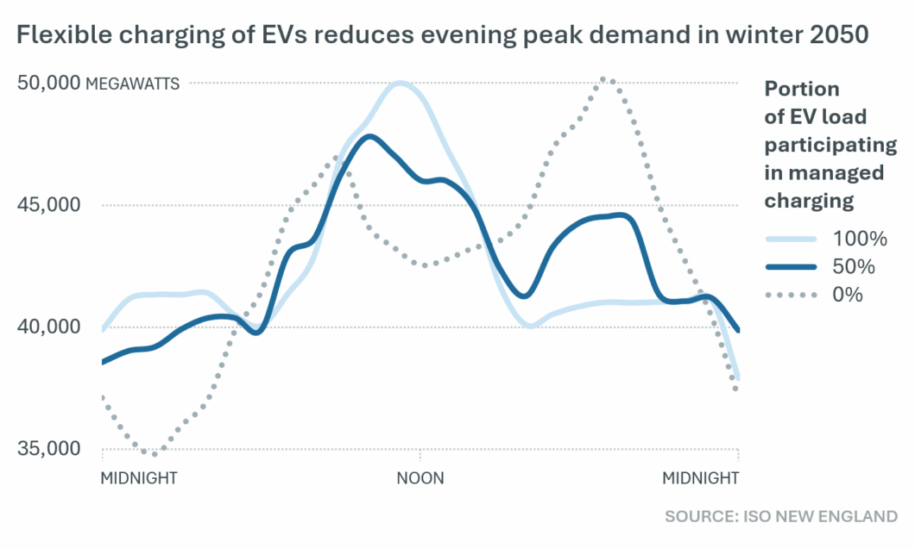
Encouraging consumers to charge electric vehicles during the day instead of at night could take better advantage of future high PV production and help reduce the need for more expensive zero-carbon dispatchable technologies. Shifting 100% of the 2050 EV fleet to a managed charging program reduces future costs by an estimated 12%, or $18 billion.

Though historically programs have targeted summer, demand flexibility can be a winter peak solution and should include heating. The potential is large for winter demand flexibility and it includes the heating sector. Winter demand flexibility can include time-varying rates, water heating control, auto demand response, interruptible tariffs, batteries, EV managed charging, industrial thermal storage, behavioral demand response, space heating control, and natural gas demand response.
Principle #6: Demand Flexibility Can Be a Winter Peak Solution

To scale winter DR, there is still more information needed to understand the problem:
- Behavioral: To what extent will customers participate?
Source: 49th PLMA Conference, Portland, OR, May 8, 2024 – presented by Ryan Hledik

- Financial: What is the incremental cost of adding winter capability?
- Operational: How to utilize gas DR for benefit of electricity system?
- Technical: What is the load shifting ability of heat pumps?
- Planning: When will the need for winter flexibility materialize?
Source: 49th PLMA Conference, Portland, OR, May 8, 2024 – presented by Ryan Hledik

Flexible load management, when cost-effective, has many ratepayer benefits. These benefits include:
Principle #7: Full Range of Ratepayer Benefits Should Be Considered

(1) Reducing a load servicing entity’s share of the costs of the bulk transmission system – also referred to as regional network service reduction (RNS);
(2) Reducing a load servicing entity’s share of capacity costs;
(3) providing frequency regulation/spinning reserve revenues;
(4) generation Constraint Management on transmission and distribution systems;
(5) T&D investment deferral/T&D support; and
(6) improved resiliency and reliability of the power system.

The function of retail electricity rates is to recover utility’s revenue requirement in the most economically efficient and equitable fashion. There are various alternatives to standard volumetric rates, many of which are time-varying rates and are enabled by AMI.
Principle #8: Retail electricity rates and time-varying rates are enabled by AMI

Policy and Regulatory Recommendations
In addition to the cross-cutting principles outlined above, a number of specific policy and/or regulatory recommendations are also provided for consideration by state commissions. These recommendations could be undertaken by individual state commissions, in coordination at the regional level, or both.
Several Working Group participants noted the importance of traditional (a.k.a. “passive”) energy efficiency programs as a winter resource. As buildings continue to convert to electric heating systems, measures such as insulation and air sealing can increase the efficiency of heat pumps, reducing baseload energy use around the clock. These measures also have potential as cost-effective measures for reducing peak demand as the region shifts back to winter-peaking status.
Recommendation #1: Consider traditional energy efficiency programs as a winter resource
As state regulators consider the optimal level of investment in energy efficiency program budgets, these additional benefits may be worth considering.

The LBNL report found that there are relatively few retail demand response programs in New England operating during the winter season. State regulators may wish to consider initiating a proceeding or investigation to explore programs and technologies that have the potential to deliver cost-effective benefits. The form these programs take could range from a series of pilot programs (along the lines of what PURA has been conducting in Connecticut) to large scale programs that are delivered across utility service territories.
Recommendation #2: Explore the creation of new winter programs
Topics which such a proceeding could cover include:
- Program objectives
- Cost-effectiveness of winter measures in the near-term when the region is not yet winter peaking
- Time(s) of day to target
- Scaling programs as the region shifts to winter peaking
- Consideration of shifting capacity benefits over time under the new prompt-seasonal capacity auction format

Time-varying rates can be designed to incentivize flexible load management in ways not possible with standard volumetric rates. There was no single approach to rate design supported by all of the working group participants, but there was a broad recognition that truly enabling retail demand response and load flexibility measures would require supportive rates to maximize benefits, particularly those related to peak demand reduction.
Recommendation #3: Consider rate design options to support programs and technologies
State regulators should consider whether a combination of time of use rates (to shift demand off peak on a daily basis) plus critical peak pricing (to reduce usage in an urgent situation, such as a winter energy shortfall) would deliver benefits. Rates should be tailored to ensure they match with potential shortfall periods, particularly late mornings during the winter season.
As noted in the general principles discussion above, care must be given to matters of affordability and equity when considering rate design changes.
The example rates below (adapted below from the presentation to the Working Group by Brattle Group’s Dr. Sanem Sergici) can be employed in retail demand response and load flexibility programs.
Rate | Definition
Time of Use (TOU) | The day is divided into peak and off-peak time periods. Prices are higher during the peak period hours to reflect the higher cost of supplying energy during that period
Critical Peak Pricing (CPP) | Customers pay higher prices during critical events when system costs are highest or when the power grid is severely stressed
Peak Time Rebates (PTR) | Customers are paid for load reductions on critical days, estimated relative to a forecast of what the customer would have otherwise consumed (their “baseline”)
Variable Peak Pricing (VPP) | During alternative peak days, customers pay a rate that varies by day to reflect dynamic variations in the cost of electricity
Real-Time Pricing (RTP) | Customers pay prices that vary by the hour to reflect the actual cost of electricity
Two-part Real-Time Pricing (2-part RTP) | Customer’s current rate applies to a baseline level of consumption. A second, marginal cost based, price applies to deviations from the baseline consumption
Three-part Rates (3-part Rates) | In addition to a volumetric energy charge and fixed charge, customers are also charged based on peak demand, typically measured over a span of 15, 30, or 60 minutes
Fixed Bill with Incentives | Customers pay a fixed monthly bill accompanied with tools for lowering the bill (such as incentives for lowering peak usage)

Rate design can include alternative rate offering(s) can be used before full AMI implementation. Near-term options can include lowering volumetric charges before moving to time-varying rates:
Source: Massachusetts Interagency Rates Working Group – June 21, 2024, presentation

Retail demand response and storage resources could serve as cost-effective alternatives to building transmission. For instance, VELCO described Vermont’s process that requires 20-year utility plans to identify reliability issues and evaluate NTAs such as demand response through a transparent participant process. Better alignment between state NTA processes and ISO-NE transmission planning would help to integrate these cost-effective, rapid to market resources.
Recommendation #4: Incorporate non-wires alternatives into transmission planning

As the region shifts to winter-peaking, seasonal demand response portfolios should scale accordingly. For example, expanding winter demand response through the use of smart thermostats, batteries, and managed EV charging, and launching local grid services/VPP offerings as loads shift to winter peaks, may all play a growing role in addressing both winter peak demand and winter energy adequacy needs.
Recommendation #5: Scale winter-focused DR portfolios and managed EV charging
ISO-NE noted that load shifting helps avoid or reduce the costs of T&D upgrades but distinct measures may be needed for addressing multi-day energy adequacy. Union of Concerned Scientists suggests that program design targets should be set against REST. ISO-NE, states, and utilities have existing tools that can aid the development of DR program design, including ISO-NE’s Probabilistic Energy Adequacy Tool (PEAT) and Regional Energy Shortfall Threshold (REST) tools. These tools should be recognized and used in program design.
Recommendation #6: Recognize and use existing tools in program design

State Regulators should consider adoption of open communications standards that enable VPPs to provide both retail and ISO-NE services. Such standards could require utilities to provide interval usage, TOU and net-metering attributes, program and event flags, and basic billing interoperability so competitive suppliers and aggregators can offer retail demand response. Additional program design considerations could include standardizing dispatch windows, baselines, telemetry and performance measurement across states to enable aggregation, and requiring any local programs coordinate dispatch to avoid double counting with ISO-NE.
Recommendation #7: Standardize and enable virtual power plants (VPPs) to participate in markets

Long-term regional planning could benefit from the development of a more robust set of retail demand response potential studies. The LBNL report noted that to date, potential studies such as this – particularly for the winter season – are very limited. If the region wishes to determine the degree to which retail demand response and load flexibility resources may help to mitigate regional peak demand growth and winter energy scarcity events, potential studies are an important foundational step in determining the possible scale of those resources. A regional approach to this task could help with cost-sharing.
Recommendation #8: Develop more robust retail demand response potential studies, particularly in the winter context

Program design requirements and standards vary from state to state, present challenges for their business models of DER providers. State regulators could help to promote the development of DERs by collaborating to develop shared standards where possible.
Recommendation #9: Explore options for cross-state, cross-utility program coordination and harmonization, including winter cost-effectiveness
As noted earlier, there was some disagreement among the participates as to whether or not winter demand response programs can be cost-effective before New England becoming a winter-peaking region. In particular, several DER providers and others disagreed strongly with statements in the LBNL report that such measures may not be cost effective at this time. Addressing this issue is important for understanding the near-term potential of winter demand response measures before the region becoming winter-peaking. While the analysis of this issue might vary state by state due to differing cost-benefit methodologies, a regional approach could also be deployed, to the extent that this issue affects every state.

Dispatch orders from ISO-NE may conflict with those from retail program administrators, potentially resulting in significant financial penalties and operational difficulties for DER providers. This risk, in turn, may suppress the full development of retail demand response resources. Given the nexus of this issue with ISO-NE operations, a regional approach which includes the state regulators, ISO-NE, utility program administrators, DER providers, and other participants might be appropriate. This approach could include characterizing the issues observed by DER providers and developing changes to operational rules at both ISO-NE and utilities to mitigate them.
Recommendation #10: Continue to address conflicts between retail and wholesale dispatch of DR resources
Coordination of retail demand side programs with ISO-NE markets and operations can avoid impacts to the system. While ISO-NE is becoming increasingly aware of utility conservation programs where load reduction occurs during peak hours on summer days and where seasonal peak loads are anticipated, visibility into these programs is limited.
As the region considers future program design, increased awareness of program characteristics will facilitate ISO’s understanding of expected load behavior under certain conditions. Specifically, the following components are of interest from ISO-NE’s perspective:
Source: ISO-NE
- Voluntary or mandatory program participation;
- Utility load control program or calls for conservation/customer reductions;
- Program magnitude (in MW);
- Event triggers (i.e., system conditions);
- Timing and duration of conservation events; and
- Methods for communicating plans to implement conservation measures, if any.

ISO-NE anticipates implementing Order 2222 in quarter four of 2026. Participants held differing views on the whether the Order 2222 tariff design in New England will effectively stimulate the development of additional demand response and load flexibility resources. State commissions can engage with relevant participants to monitor the impacts of Order 2222 as it takes effect and assess the degree to which it is or is not supporting the deployment of new resources. If it is not, state commissions can consider engaging with participants either individually or on a regional basis to explore modifications which could improve the efficacy of the Order 2222 compliance framework. State commissions can also evaluate the degree to which existing or planned programs will support Order 2222 requirements. For instance, most New England states either have deployed or are in the process of deploying advanced metering infrastructure (AMI). State regulators should evaluate whether existing and planned AMI technologies can support Order 2222 metering requirements.
Recommendation #11: Monitor impacts of Order 2222 compliance

Section VI Topics for future consideration
The Working Group did not exhaust all aspects of the topic of retail demand response. The following topics may be of interest for future consideration in some form:
- Natural gas demand response programs: This Working Group did not take up the issue of natural gas demand response. There was broad agreement that improving understanding of the potential for these products would be important in assessing the overall potential for demand-side resources to address regional winter energy adequacy challenges.
- Topics from the Working Group charter that were not taken up:
  - Real-time operational reliability (e.g., ramping); and
  - Matching demand with renewable energy generation
VII. Appendix
Recommendations from Participants
Participant | Category(s) | Principle
Avangrid | Existing programs; technology | - Existing DR/EE programs can be adapted for winter  - Fund pilots to test and replicate emerging technologies  - DR is just one tool in the toolkit  - Investments and capabilities need to operationalize pilots and invest in new technologies  - Advanced distribution system technology will play a crucial role
AEU | Wholesale markets; rates | - Find opportunities to enhance wholesale market rules to encourage DR participation  - Address issues related to sub-metering and telemetry requirements and dual participation  - Implement AMI to enable data collection and programs  - Dynamic pricing (TOU or real time) for rates is important  - Capacity accreditation issues for DR are problematic  - State programs need to adapt to meet the needs of winter energy adequacy
Brattle Group | Technology; rates | - Nearing the point where devices are able to respond automatically to prices – but important to recognize some consumers may still want to have control, so it’s important to provide a variety of options  - TOU plus CPP might be an ideal rate design for systems with growing RE penetration  - TOU enables daily load shifting  - CPP activated rarely, in response to extreme days of system constraints  - CPP events can also be called locally for distribution level constraints  - Utilities should work on time-varying rates so they are ready to deploy when AMI comes online  - Small behavioral changes (such as those created by a default TOU rate) can have big impacts on the winter peak load as electrification continues
CPCNH | Wholesale markets; technology | - Create “local energy markets” for DERs  - Improve data sharing  - Address wholesale load settlement issues negatively impacting DR and load flexibility  - Use customer-specific capacity tags for load settlement (increasingly possible as AMI is deployed more broadly)  - Revise transmission cost allocation practices which are not fully valuing DR value streams such as avoided T&D costs  - Implement consolidated billing practices to enable retail suppliers to offer supply rates for intervals shorter than one month  - Deploy a retail market platform similar that offered by Piclo
CPower | Program design | - Design programs which will attract a wide variety of participants  - Ensure programs are not overly complex in their design or requirements  - Enable a wide range of technologies to participate  - Include consideration of environmental goals and impacts
CPower | Regional consistency | - There are numerous areas where programmatic consistency would be helpful to DR providers, however this must be balanced against the value of individual states continuing to improve their own programs  - Consistency of program structures is the most important aspect of regional coordination
CPower | Wholesale markets | - The complexity of the wholesale market is discouraging DR adoption  - The Pay for Performance (PFP) system is creating unacceptable risks for some DR customers  - Capacity prices currently are not high enough to motivate DR engagement  - Order 2222 compliance filings fail to address known issues  - Allocate winter and summer costs separately based on each season’s peak hour, to create more incentives for winter DR
Enel | Regional consistency | - Set incentive levels properly; provide consistent rules-based dispatch  - Aggregators have to have separate metering and processes in place for each utility – can this be fixed?  - Alignment of dispatch timing would be valuable
GridX | Rate design | - Focus on effective design of time-varying rates  - Prioritize personalized rate education and other customer empowerment tools
IceTec | Program design; rate desgin | - Program must be simple/feasible enough to encourage strong participation  - Payments must be reasonable  - Program design needs to be both stable and responsive  - Integration of retail rates with wholesale markets  - Programs need to provide community benefits  - Customers need trusted implementers
National Grid | Existing programs; program design; rate design; technology | - Continuation of EE programs (e.g., weatherization) to permanently reduce peak lead  - Drive more adoption and program enrollment of flexible DERs (e.g., BTM storage) that could support load flexibility for future winter peaks:  - Continued growth of system-wide DR and EV managed charging programs  - Deployment of heat pumps, smart thermostats, and storage to mitigate summer and winter peak demand (Generac pilot project)  - New local grid services/VPP offerings to leverage customer and third party DER flexibility  - Price signals via time-varying rates  - Future cost-effective winter DR  - Explore innovative technologies (e.g., thermal storage)
Oracle | Market design; program design | - Value retail market reductions in demand  - Review IIJA updates to PURPA  - Create passive demand reduction goals or BCA value  - Address consumer communications challenges
Piclo | Market design; regional consistency; rate design | - Incentive payments – how will utilities get cost recovery for software innovation  - Simply the process – DER aggregators don’t want to be repeating administrative processes for every different state/program/etc.  - DER visibility – how will system operators and utilities get a visual on the DER assets available to them?  - CAPEX/OPEX vs TOTEX – proper incentives are needed to encourage adoption flexible demand technologies  - Tariffs and markets/programs – utilities need more tools to nudge customers and aggregators to adjust their load and interact with the grid
RMI | Technology; program design | - Advance policies to expand beneficial DER adoption by diverse end-users.  - Enable inclusion of all DER technologies in VPPs.
RMI | Program design; wholesale markets; technology | - Utilize best practices in program design.  - Use open communication protocols and standards.  - Enable VPP participation in wholesale and retail markets.  - Regularly update grid service needs to reflect the evolving grid.  - Support comprehensive utility planning and investment decisions.
RMI | Market design | - Fairly compensate VPPs for services delivered.  - Enable value stacking to maximize benefits.  - Support policies that value VPP contributions to resilience, reliability, and sustainability.  - Uphold equitable penalties and liabilities.
RMI | Program design | - Maintain customer choice in DER operational control.  - Uphold customer data ownership and simplify enrollment.  - Protect and educate customers.  - Support customer participation in structuring VPP offerings through procedural equity.
RMI | Technology; market design | - Encourage participation of competitive hardware and service providers.  - Use open-source software and make grid data available.
Union of Concerned Scientists | Wholesale markets | - DR programs should be designed to reflect the outputs and requirements of PEAT and REST  - ISO-NE’s analysis of potential from conservation appeals could provide insight into DR potential more generally

Charles Dawson from the Massachusetts Dept. of Energy Resources was instrumental in leading the development of this template.
Some of these issues are starting to be addressed through increased coordination and information-sharing between utility program administrators and ISO-NE controllers, as discussed earlier.
(LBNL report, pg. 10, emphasis in the original)
With the current Order 2222 ISO-NE compliance framework not yet having taken effect, this report does not advocate for reopening wholesale market rules until there is an opportunity to assess the impact of the current rules on DER participation in wholesale markets.

